Contents
Foreword 2
1. Engaging with the People of Wales and Widening Public Engagement 3
2. Supporting our Workforce: the Assembly Commission as an Employer of Choice 16
3. Supporting Assembly Members, their Staff and Assembly Business 25
4. Embedding Equality into our Work 33
Annex A: Workforce and Recruitment Monitoring Data 35
Annex B: Equal Pay Audit and Gender Pay Gap Reporting 2017 70

Foreword
This report provides an update on activities related to diversity and inclusion activities over the period from 1 April 2016 to 31 March 2017. This period spans the expiration of our previous equality scheme and the development of the Assembly Commission’s Diversity and Inclusion Strategy for the Fifth Assembly.
This year has seen teams working collaboratively to realise our goals to further develop our workplace equality networks, build capacity across our organisation to undertake equality impact assessments, continue to take steps to address underrepresentation in our workforce and endeavour to engage the broadest range of people in the work of the Assembly.
Looking ahead, we will focus on delivery on our objectives set out in our Diversity Plan for the Fifth Assembly. Our areas of focus include fostering inclusive leadership and an inclusive workplace culture, assisting our staff, Assembly Members and their staff to build diversity and inclusion into their work and behaving as an inclusive employer that attracts and retains a broad range of talent.
As ever, we welcome feedback on our approach to the way in which we value diversity and further inclusion in our organisation and look forward to continuing progress in reaching our goals set out in our Diversity and Inclusion Strategy.
Manon Antoniazzi  Chief Executive and Clerk to the Assembly | Joyce Watson  Assembly Commissioner with responsibility for employees and equalities

- Engaging with the People of Wales and Widening Public Engagement
One of the strategic goals of the Assembly Commission is to engage with all of the people of Wales and to champion the work of the Assembly. It is important that the Assembly represents all of the people of Wales and that everyone has access to our work, our buildings and our information.
During this reporting period, we have developed a new Public Engagement Strategy that will inform our priorities for public engagement. The purpose of the new strategy will be to plan the delivery of services that connect and engage with all the people of Wales, by informing and involving all the people of Wales in the Assembly’s work, and introduce ways that empower them as citizens to directly influence and take pride in the parliament’s work. Particular attention will be given to developing services that engage those who do not currently engage with the Assembly.

Major public engagement initiatives
In November 2016, we announced:
- the establishment of a Youth Parliament for Wales, supported and funded by the Assembly Commission; and
- the establishment of a Digital Information and News Task Force.

Overview of community and youth engagement
In the last year, we have welcomed thousands of visitors to our estate and interacted with people across Wales in a variety of different ways. Below we celebrate some of our engagement work and share some of the highlights of the year.

CASE STUDY: #SeneddNewport
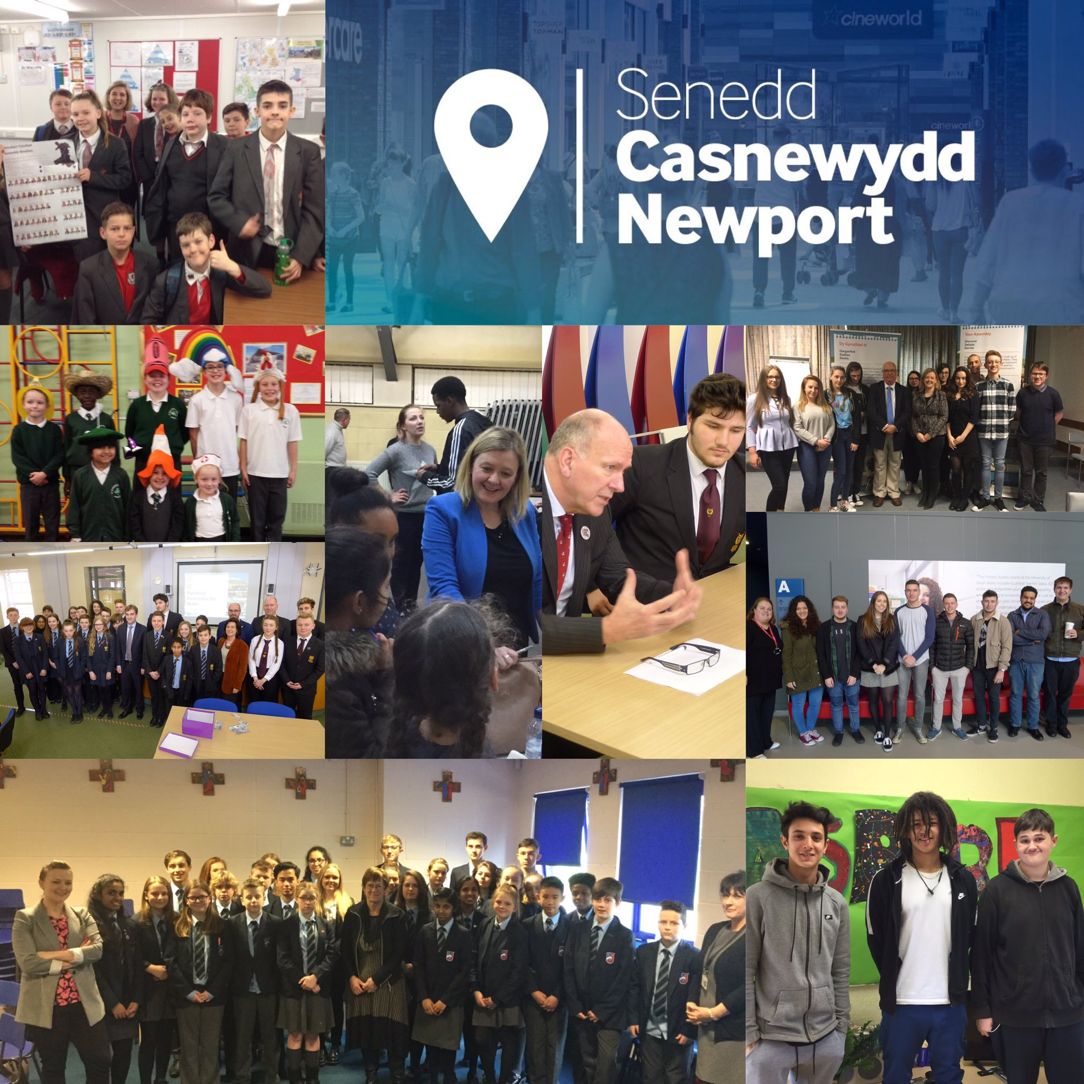
Building on the success of our visits to Wrexham and Swansea, we took the work of the Assembly to Newport for a week in March 2017. The week’s activities were delivered in partnership with the South Wales Argus and the University of South Wales. During a busy week, three committees held formal meetings in the Newport campus of the University of South Wales; two of our committees visited local schools; our outreach, youth engagement and education teams delivered 30 information sessions; the Llywydd held a reception for local organisations and individuals; and we took a public engagement stall to the Friar’s Walk Shopping Centre.
As part of this week, the Deputy Presiding Officer, Ann Jones AM, had a series of meetings with key local stakeholders to discuss how the Assembly connects with women. The Deputy Presiding Officer’s meetings focused on improving how the Assembly engages with women who may feel disempowered and disengaged. Over the course of an afternoon, the Deputy Presiding Officer met with women in refuge at Women’s Aid Newport, refugee women at the Welsh Refugee Council and members of staff at SEWREC. The Deputy Presiding Officer fed back her findings from these meetings to the local Assembly Members and the relevant Cabinet Secretaries.
During this event, we engaged directly with over 1,900 individuals and established links with numerous schools, youth groups and other organisations.

Understanding and engaging sessions
Our Outreach Team held fifty-three “Understanding and Engaging” sessions for 1,076 delegates over this year, involving a range of groups, including the British Deaf Association, Action on Hearing Loss, Citizens’ Advice Bureau staff and volunteers, Evangelical Alliance Wales and Gingerbread. These session introduced attendees who might not have necessarily interacted with the Assembly before, to what the Assembly does, outlining the election of Assembly Members and who their representatives are, how to hold the Welsh Government to account and how they can engage with Members and the work of the Assembly.

Education and youth engagement
Our Education and Youth Engagement team have informed, involved and empowered children and young people to engage with Assembly Business both in our in-house education centre and at schools, colleges and out of school settings across Wales.
We have worked with 151 youth groups in out-of-schools settings, engaging with some groups for the very first time, including 3G's Development Trust, ACT Training - Aberdare Centre, Afasic Cymru – Neath, Barnados Young Carers Flintshire, Blaenau Gwent Youth Forum, Ceredigion Youth Service, Cwmbran Centre for Young People, Deffo!, Digartref Ynys Môn - Community Voice, Newport YMCA, Newport Info Shop, Omidaze Productions, Pembrokeshire Voices for Choices, RCT Community Youth Forum, Swansea Young Single Homeless Project – SYSHP, The Point Young Persons , TrustVale People First, Whizz Kids - Conwy.
During this reporting period, a total of 653 sessions and events have been delivered, reaching over 27,000 young people.
CASE STUDY: Digartref Ynys Môn
A group of ten young people, supported by homelessness charity Digartref on Ynys Môn have been working with our outreach team as a part of their Community Voice project. As part of the project the group, aged between 16-25 years old, took part in a Wales 2016 election workshop, held a mock election, attended the polling station on Election Day and took part in two full workshops at the Assembly in Cardiff.

CASE STUDY: Black History Month
In October 2016 young people from Grangetown and Butetown Youth Pavilion visited the Assembly and spent time asking questions to the Llywydd as part of Black History Month.

Promoting diversity and inclusion
As part of our commitment to being an inclusive organisation we continue to promote diversity and inclusion to our staff and to the public via events, social media and campaigns.
We have continued to use social media to reach a wider audience, promoting a diverse range of campaigns and key dates in the diversity and inclusion calendar, including Stonewall’s No Bystanders anti-bullying campaign during Anti-bullying week; our Diversity and Inclusion week; LGBT History Month; Holocaust memorial Day; Black History Month; Disability Access Day; World Autism Awareness Day; celebrating external recognition that we have received; a campaign to end violence against women; Pride Cymru; Trans Day of Visibility; youth engagement; and Swansea Sparkle.
We have encouraged people to think of the Assembly as an inclusive organisation, encouraging them to get involved with the work of the Assembly and to consider the Assembly as a potential employer of choice.
Here are some of the highlights of our promotional work:
- We attend Pride Cymru every year, as part of our summer events programme. In 2016, we were proud to march alongside many other organisations and individuals as part of the official Pride parade before welcoming attendees to our outreach bus on the main site.
- Alongside other iconic buildings across the world, the Senedd was lit purple on 8 March to mark International Women’s Day 2017. We also delivered an event in partnership with Wales and West Cross Government Women’s Network, which delivered a series of ‘power talks’, a lunchtime reception and networking fayre and an evening drinks reception in the Senedd. The event involved up to one hundred and fifty women.
- Rhondda and Pontyclun Hard of Hearing Groups, Sense Cymru and service users from the National Autistic Society Cymru were invited to visit the Senedd over the weekend of Disabled Access Day to celebrate the Assembly as a welcoming and accessible venue for all.

- The Llywydd Elin Jones AM, Joyce Watson AM Assembly Commissioner with responsibility for equality and Andrew White, Director of Stonewall Cymru, promoted ‘By Your Side’, Stonewall’s campaign asking LGBT advocates and allies to pledge their commitment to continuing to work towards LGBT inclusion.
- We celebrated Black History Month in October by holding a series of events within the Assembly, attended community events and wrote blog articles in order to promote engagement with the Assembly to BME people.
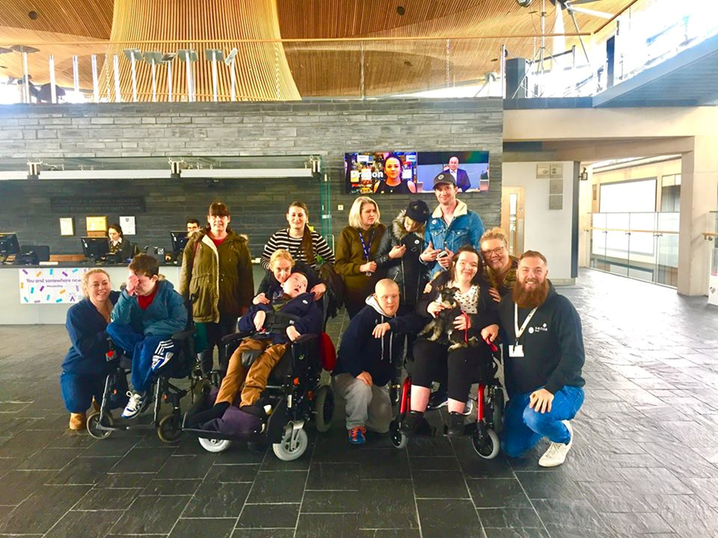

Visitor attraction
The Assembly estate continues to be a popular visitor attraction. During this reporting period, we welcomed nearly 83,680 visitors to the Senedd and nearly 82,962 people to the Pierhead Building. People have visited from all over the world to enjoy our buildings, to watch Assembly Business, have a tour, attend an event or to visit our café and shop. We are listed on TripAdvisor as one of the top visitor attractions in Cardiff and we are proud to have received their Certificate of Excellence.
We promote the Assembly as a visitor attraction through connections with the local Cardiff Bay Waterfront Partners Group, through social media, through our outreach work and through Euan’s Guide, a listings and review website that helps disabled people and their families know which venues are accessible.

Feedback from visitors, which included a group of asylum seekers and refugees and a group of disabled children and young people:
- As a group that suffer hearing loss it's not always easy when we visit places, you made us feel so welcome and thanks to the equipment provided, we were all able to hear. A BIG thank you from all the group, we hope to visit again in the near future.

- Many, many thanks. Our tour guide was brilliant, pitched it perfectly, engaged everyone and was spot on with timing. Very impressive. They loved it!

- Service received was “over and beyond the call of duty

- our tour guide was great. He used appropriate content and speed in his delivery. However right from the security check at the entrance, all members of staff were great.

- We visited with a group of young people, all with additional needs. Accessibility is fantastic, and our tour guide was excellent. Thank you for this opportunity.

CASE STUDY: Senedd Family Fun Day
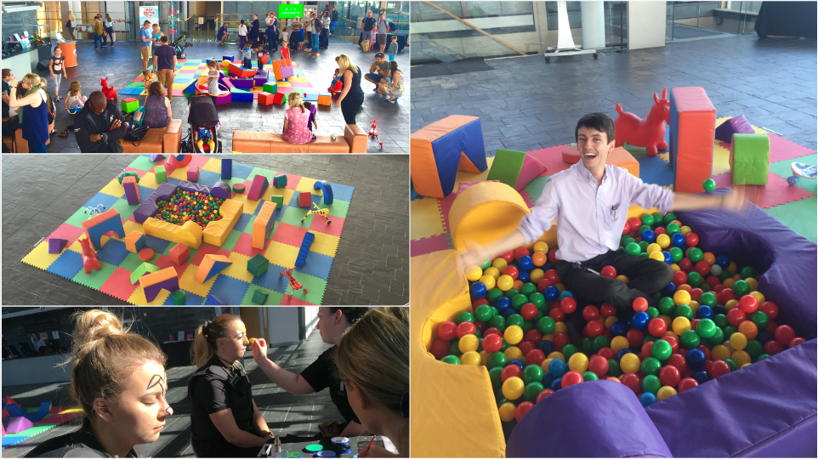
Over the August bank holiday weekend 2016, we hosted Senedd Summer Fun, a free event for people of all ages to enjoy. During the event we had a soft play area, Lego station, arts and crafts, choirs singing, Techniquest offering fun scientific games and activities, there were tours of the building running every 30 minutes, and discussing the work of the Assembly. We also commissioned a local community art group to create an exhibition to be shown in the Senedd for the duration of the event; the exhibition focussed on Wales, Welsh culture, history and what it is like to live in Wales today. There were 3,500 attendees over the three days which saw us attract local families to the Assembly who might have not ordinarily visited our buildings.

Online Accessibility
Following an accessibility audit of our website, we have made a number of accessibility improvements that are aimed at improving the overall transparency of our website information. These changes include:
- redesigning the homepage and top-level pages to display the types of information users access on a regular basis;
- creating a new ‘mega-menu’ to allow users to navigate more quickly to other items of interest; and
- changes to Assembly Member biography pages to make it easier to access their plenary speeches and how they’ve voted.
In addition to this, our Digital Team has worked closely with our website publishers to raise and maintain standards in relation to website publishing, which is a vital component of trying to maintain standards.

MySenedd – making improvements to the way that we work
The MySenedd programme is a series of projects designed to improve the way we manage and use information, deliver services to Members and interact with all our users through the use of technology. The programme aims to create a truly outstanding, open, digital parliament.
When designing elements of the Programme, we completed equality impact assessments as part of the formative stage, the outcomes of which are integral to the development and decision making process, ensuring that our design solutions take account of a diverse range of needs.

CASE STUDY – Rich Picture – inclusive communications
We engaged a Royal National Institute for Blind People (RNIB) trained local design company (Scarlet Design) who have specific diversity and inclusion expertise, to articulate our future vision of the MySenedd programme in an engaging, informative and easy to understand way. As part of the brief the ‘Rich Picture’ would consist of a mixture of words and pictures and be available in Welsh and English.
The finished pictures depict Assembly staff, Assembly Members and the ‘People of Wales’. They reflect the diversity of our staff and service users, and the high importance we attach to meeting our equalities duties when redesigning our services.

Accessible estate
We continually review the accessibility of our estate, undertaking monthly maintenance audits, as well as acting on feedback and adopting best practice. During this reporting period, we have undertaken further work to improve the physical accessibility of our estate, including:
- widening the access ramp in the underground car park at the main atrium stairwell/ lift lobby;
- installing ramped access to the new sound/ translation booths for the new committee rooms;
- installing new signage, including braille, to new committee rooms and meeting rooms;
- providing a new quiet room on the ground floor;
- installing new signage, including braille, following lift refurbishment;
- installing new signage, including braille, in all shared toilet and shower room facilities throughout the estate;
- considering access requirements for all refurbishment work that been carried out;
- continuing with the programme of installing LED lighting to improve visibility in the Senedd and other areas across the estate; and
- reallocating some toilet and shower facilities as ‘gender neutral’ or ‘gender neutral and accessible’.
FEEDBACK - “Fabulous! Love the gender neutral loo!”

Learning and improving – name change consultation
Between 8 December 2016 and 3 March 2017, the Assembly Commission ran a public consultation on changing the name of the National Assembly for Wales. Respondents were asked to provide equality monitoring data to help the Commission to assess the representativeness of the sample. Following feedback from members of the public, we identified a need to learn and improve from this and subsequently reviewed our methodology for gathering equality monitoring data and identified best practice to inform future initiatives.

Going forward:
We will evaluate relevant data and use best practice to inform how we continue to build diversity and inclusion into:
- developing an inclusive and effective youth parliament;
- promoting access to our information and our estate;
- promoting diversity and inclusion as an employer and parliamentary organisation;
- implementing our Public Engagement Strategy which will ensure that we continue to engage with a diverse range of people across Wales and people who have not engaged with the Assembly before; and
- implementing the MySenedd programme to identify and implement technological improvements to increase our engagement opportunities.
- Supporting our Workforce: the Assembly Commission as an Employer of Choice
We strive to be an inclusive employer of choice where all of our staff can thrive in a safe and supported environment.
Our workforce and recruitment data, and an equal pay audit can be seen in Annexes A and B respectively.

Arrangements to support Commission staff
We have a number of policies and initiatives in place to support our staff and help us promote equality, foster good relations and remove discrimination. These include:
- dedicated teams and workplace equality networks that provide a range of advice and support;
- a variety of flexible working arrangements that enable staff to find a working pattern that suits their needs;
- using our workplace equality networks to impact assess our policies to ensure they are fair and inclusive;
- an Employee Assistance Programme that offers a counselling and advice service to staff;
- health and wellbeing policies in place which include a mental health policy and policy for supporting staff who are experiencing domestic abuse. Such policies are supplemented by ongoing awareness campaigns that highlight how staff can access both peer support and an on-site occupational health nurse;
- annual Display Screen Equipment (DSE) assessments and reasonable adjustments for those that need them;
- an annual Diversity and Inclusion Week to raise awareness of different equality issues and promote the support available to staff; and
- regular awareness-raising initiatives on equality–related themes to inform staff and Assembly Members, including factsheets, training and a monthly Diversity and Inclusion Bulletin that lists relevant news, publications and consultations.

Apprenticeship scheme
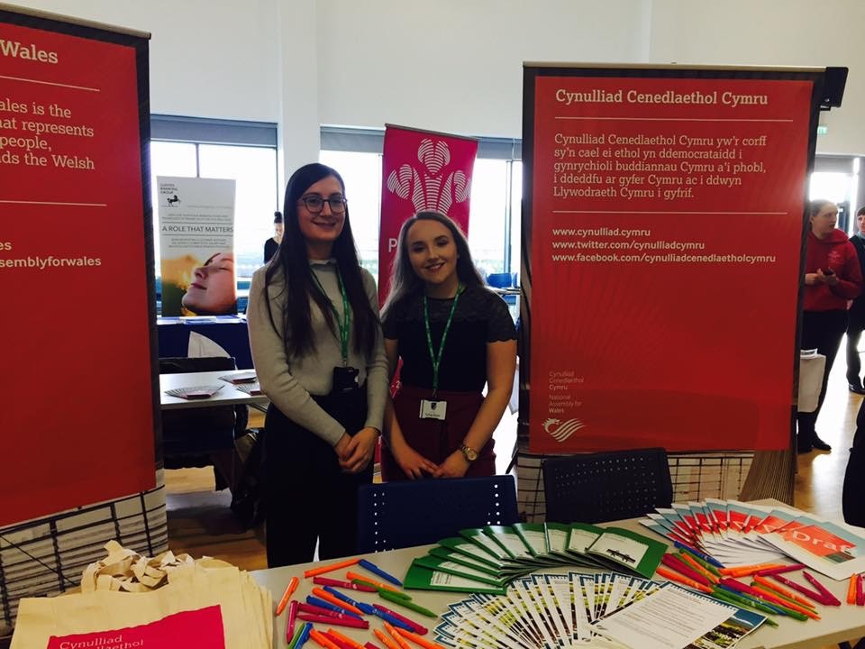
Following the previous successes of our apprentice scheme, we welcomed four new apprentices in September 2016. Working towards their Business and Administration diploma, they are the first cohort of apprentices to experience the rotational programme on offer at the Assembly. They will experience five months in different teams to fully enhance their experience whilst working here. Our apprentices are paid in line with the accredited Living Wage scheme, which is higher than the usual apprentice rate.
The apprentices have already proved to be assets to their teams, assisting on projects as well as outreach work at career events across Cardiff promoting apprenticeships. They have also undertaken fundraising events at the Assembly and will shadow Assembly Members later in 2017.
Our apprenticeship programme provides work-based learning for young people, but also presents them with life changing skills and experiences. We see their confidence grow and their strengths highlighted in a new environment. One apprentice has positively progressed his volunteering work outside of the Assembly since working here, participating in talks at Westminster and Poland and working with representatives from Greece, Estonia, Poland and Syria. We now look forward to initiating the process to recruit our next intake of apprentices for the future.

Mental health in the workplace
During this reporting period, our wellbeing strategy concentrated on mental wellbeing and included the delivery of a Mental Health Awareness Week. During the week:
- the Assembly Commission signed up to the Time to Change Wales pledge to end mental health stigma;
- we launched our mental health policy that had been designed with the assistance of a group of staff who have experienced mental ill health;
- we introduced a member of the Management Board as our Mental Health Champion;
- we held Time to Change talks, where staff were able to hear directly from people who had experienced mental ill health; and
- we delivered mental health awareness training to staff.

Flexible working
We have a range of flexible working options for staff. During National Work Life Balance week, which is an annual campaign to encourage employers and employees to focus on wellbeing at work, our flexible working options and the support that we have in place were promoted to staff. These policies have resulted in us being named as one of the best family-friendly places to work in the UK by Working Families. We were the only Welsh organisation named in the Top 10 Employers Working Families Awards and, as such, we are proud to be an exemplar employer to other organisations in Wales.

External recognition
During this reporting period, we were proud to receive new or ongoing external recognition for our diversity and inclusion activities, which include:
- being ranked fifth in Stonewall’s Workplace Equality Index 2017, ranked the top public sector employer in the UK and named the Top Public Sector organisation in Wales for the fourth year running. Ross Davies, our Diversity and Inclusion Manager, was also named Stonewall Cymru’s Ally of the Year;
- retaining our National Autistic Society Award for being an autism-friendly employer and service provider;
- being listed as a top 10 family friendly employer in the UK by Working Families Organisation;
- being designated as a Disability Confident Employer and Age Positive Employer;
- winning an Action on Hearing Loss Cymru Excellence Award for our service to people who are deaf or have a hearing loss;
- retaining the Investors in People Gold Standard, the international mark of global excellence. Organisations that meet the world-recognised standard reflect the very best in people management and our achievement of the gold award demonstrates our continuing aim of being an employer of first choice; and
- we were reassessed by Action on Hearing Loss for their Louder than Words Charter Mark and are awaiting the decision.

Workplace equality networks
Our workplace equality networks help us to promote inclusion internally and externally by taking forward diversity campaigns, providing peer support, sharing best practice and by helping the Assembly Commission to consider equality, diversity and inclusion in our work.
Following a membership drive as part of our Diversity and Inclusion Week 2016, we saw the number of members and allies increase.
Our staff network co-ordinator has supported the networks to collaborate and to contribute to equality impact assessments undertaken by Assembly Commission staff. We currently have senior diversity champions for race, sexual orientation and gender identity, gender, working families and mental health. We hope to secure a senior champion for disability in the next reporting period.

CASE STUDY: Black History Month
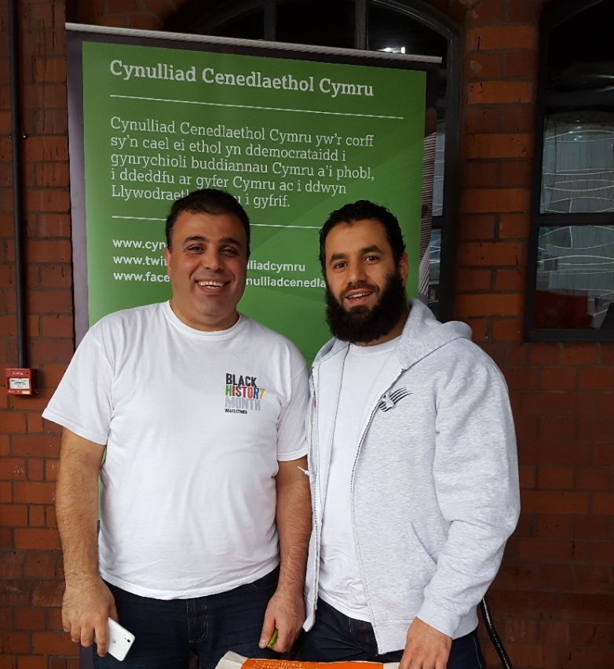
For Black History Month (BHM) in October, we had a range of activities to help promote race equality:
- Our Race, Ethnicity and Cultural Heritage (REACH) workplace network promoted the concept of unconscious bias and provided tips to staff on how to recognise and address biases.
- We held a panel talk to acknowledge World Mental Health Day (WMHD), which fell on the 10 October, where people from various protected characteristics discussed the mental health issues faced by them or within their communities, including the Black Minority Ethnic (BME) community.
- A BME Youth Engagement Question and Answer Session was held with the Llywydd, Elin Jones AM.
- We attended BHM community events to promote the Assembly as an inclusive organisation and employer of choice; and
- published a suite of tweets and blog articles related to BHM.

Underrepresentation in our workforce
We have continued to develop an approach to address the underrepresentation of people who identify as Black and Minority Ethnic (BME) or disabled in our workforce. This work is building upon our existing BME action plan to support and develop our current BME colleagues and also to attract and recruit people from the widest pool of talent, so that our workforce is reflective of the population it serves. Scoping work has taken place in this reporting period for developing tools for staff in managing unconscious bias and reviewing our methods for attraction and selection.
Our workplace networks play a vital role in helping us to take forward this agenda.
Members of our Diversity and Inclusion Team are part of the Black, Asian or Minority Ethnic (BAME) BAME Challenge, established by the Speaker of the House of Commons, to refocus energy and commitment in UK workforces to ensure that businesses attract, recruit, retain and develop BAME colleagues to help them reach their potential. A report from the BAME challenge will be published later in 2017.

Learning and development opportunities
In addition to our mandatory induction training and online equality learning, we continue to offer a suite of learning and development opportunities to Commission staff.

CASE STUDY: Diversity and Inclusion Week 2016
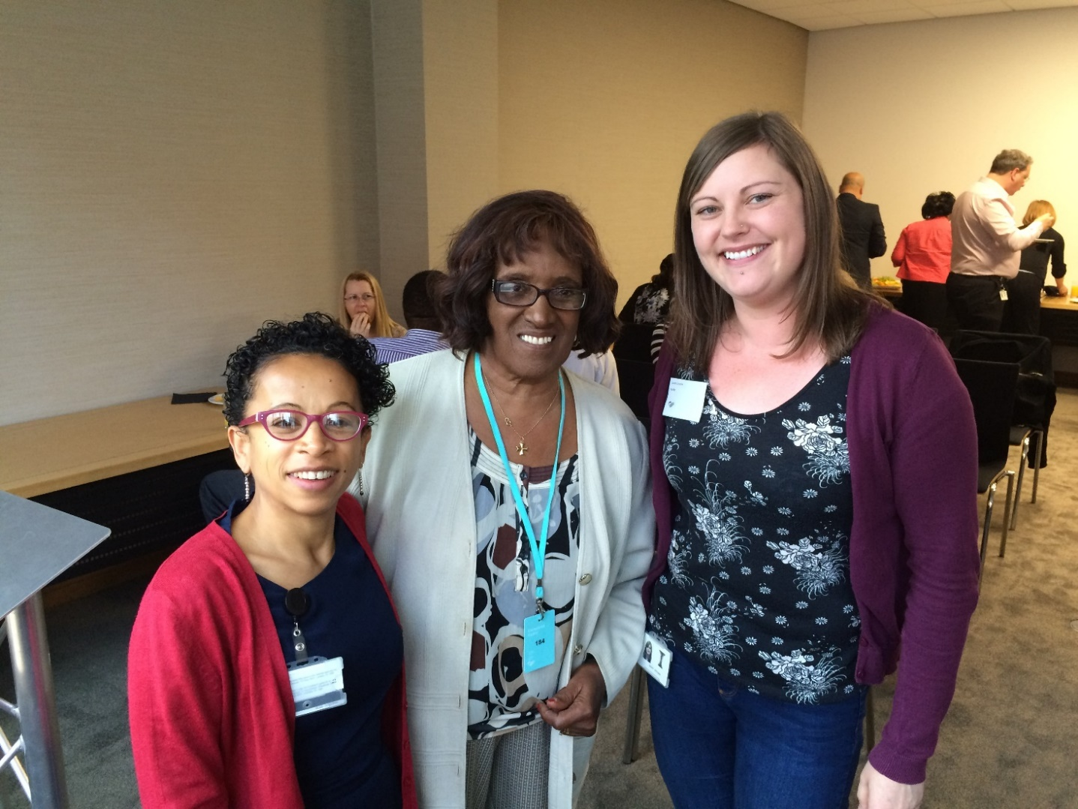
As part of our annual Diversity and Inclusion Week we raised awareness of a number of issues and promoted the Assembly as an inclusive organisation. This year was especially busy. We provided training on disability confidence, dementia awareness, supporting LGBT colleagues and an introduction to deaf awareness and British Sign Language. Our BME and women’s workplace networks invited guest speaker Betty Campbell MBE to talk about her career as the first Black head teacher in Wales.
In our internal and external communications we covered a range of issues, including unconscious bias, inclusive staff policies, human rights in Wales, equality impact assessments, invisible disabilities, text relay telephone service, promoted our BME workplace champion and promoted our workplace equality networks. We had a great response from staff and a lot of engagement with our social media outputs.

Going forward:
We will evaluate relevant data and use best practice to inform how we continue to build diversity and inclusion into:
- supporting and developing our workplace equality networks and senior diversity champions;
- identifying and acting on opportunities to promote the Assembly as an employer of choice to potential employees, including creating opportunities for disabled people and BME people to undertake work experience placements within the Assembly;
- further developing our approach to recruitment and attraction to encourage more people to consider the Assembly as an employer of choice, including updating our website and undertaking recruitment outreach activities;
- participating in relevant benchmarking and accreditation activities to ensure that we remain and inclusive employer and service provider; and
- promoting equality, diversity and inclusion to our staff through training, events and sharing information to further their understanding of the different needs and experiences of their colleagues, visitors and service users.

- Supporting Assembly Members, their Staff and Assembly Business

Continuing professional development
We continue to offer a suite of training opportunities that is flexible yet tailored to the requirements of Assembly Members and their staff. Wherever possible, continuing professional development activities are provided taking into account Members’ other commitments. During this reporting period, Members and their staff have accessed diversity and inclusion related learning; which includes:
- Supporting LGBT colleagues;
- Disability confidence;
- Dementia awareness;
- Understanding the autism spectrum;
- Conversations with vulnerable people;
- Mental health First Aid;
- Mental health awareness;
- Introduction to welfare benefits;
- Management training highlighting diversity and equality in the workplace;
- conferences covering topics such as mental health and integrated care;
- diversity and equality as part of the Assembly Member Support Staff induction;
- online training on having an inclusive workplace; and
- Caseworker training, highlighting issues affecting disadvantaged groups.

Equality and access fund
The Equality and Access fund is used by Assembly Members to engage with their constituents and to provide reasonable adjustments for Members and their staff. During this reporting period, the fund was used in a variety of ways, ranging from providing translation facilities at meetings with constituents to improving access to Members’ constituency offices. On several occasions, the fund has been used by Members for British Sign Language interpretation, to communicate with constituents at meetings and events hosted by Members. The fund has been used by Members in to improve access, including: translation of correspondence into Braille to engage with a blind constituent and installation of a ramp to ensure wheelchair access to a constituency office.
CASE STUDY: Assembly engagement in community languages
One Member used the Equality and Access Fund to engage with members of the Chinese community within their region. They identified the need to ensure information is readily available in the language their constituents find most accessible. They requested to produce and translate an existing Welsh and English bilingual document into Mandarin, enabling information to be communicated to constituents whose first language is Mandarin.

Information, guidance and awareness-raising
Our teams across the Assembly provide specialist advice and guidance to Assembly Members by:
- providing employment, recruitment and management advice to Members;
- building equality considerations into briefings and research provided to Members and committees;
- providing a suite of diversity information on our internal intranet, including Members’ obligations under the Equality Act 2010;
- ensuring Members and their staff can participate in our workplace networks and diversity and inclusion awareness-raising initiatives; and
- making health and safety support and Personal Emergency Evacuations Plans available.

Engagement with the work of committees
We continue to utilise innovative methods of engaging with people in the work of the Assembly, including applications such as Dialog and Loomio to promote online conversations with a diverse range of communities across Wales.
We look at different ways that people can submit evidence and when inviting people to submit evidence for committee inquiries, we provide guidance on how they can make their written submissions more accessible.
CASE STUDY: Focus groups with young people with additional learning needs
In scrutinising the Additional Learning Needs and Education Tribunal (Wales) Bill, the Children, Young People and Education Committee partnered with SNAP Cymru and Children in Wales to directly involve young people in the Stage 1 scrutiny of the Bill.
Committee Members attended workshops with young people with additional learning needs to gather their views. In addition to the workshops, a survey was promoted to enable a wider number of young people to have their say on some of the issues the Bill sought to address: the current level of support they receive, who should be entitled to support and where they felt they should receive information and support from.
The groups included Afasic Cymru in North and South Wales, Dynamic Wrexham, Bridgend College, EOTAS group, Ysgol y Gogarth, Coleg Sir Gar, Vale People First, Ysgol Uwchradd Aberteifi, CAVC, Heronsbridge School, Bridgend and St Christopher’s School.
The contributions made by young people helped the Committee in its deliberations and informed the recommendations it made in its report.

CASE STUDY: Empowering young people to submit a petition
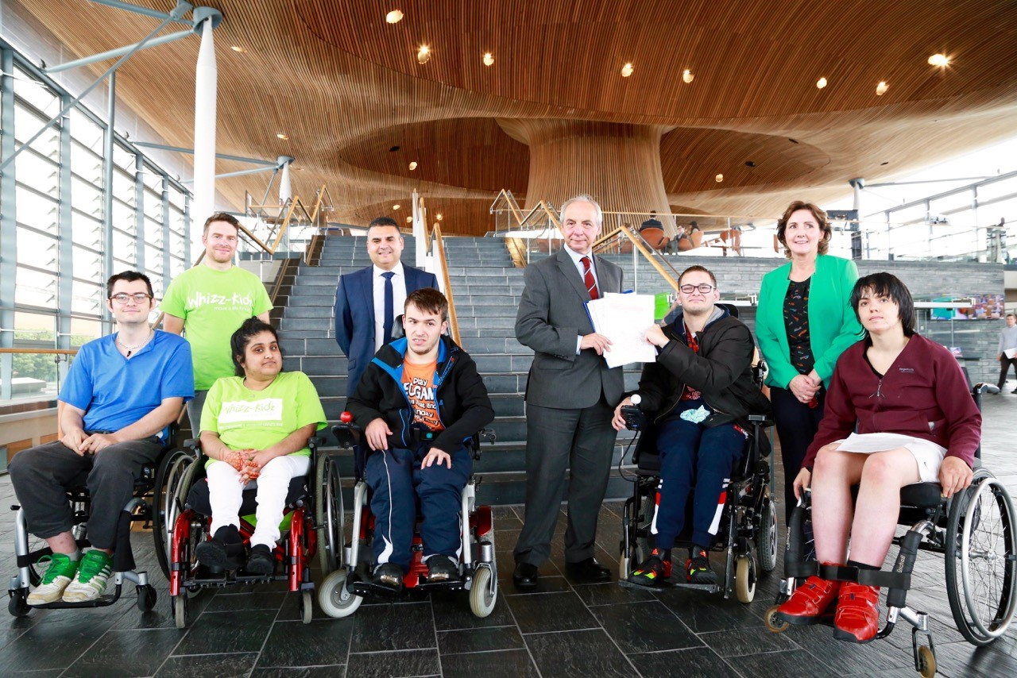
Our Youth Engagement and Education team have worked with different groups of young people from the Whizz Kidz charity in North, Mid and South Wales. One of the groups worked with the team to develop a video, which they submitted as evidence in front of the Petitions Committee.

CASE STUDY: Support available for refugees and asylum seekers
As part of the Equality, Local Government and Communities Committee summer consultation on its forward work programme, the support available for refugees and asylum seekers in Wales was a top priority for its stakeholders.
Members went out to visit support groups in the Newport, Swansea and Cardiff areas: three of the largest Home Office Dispersal Areas in Wales. The purpose of these visits was to speak directly with refugees and asylum seekers and those who support them, to understand what the main problems are for refugees and asylum seekers, particularly around access to health services, housing, education and employment.

The Committee used the information gathered to help form the questions they went on to ask organisations and the Welsh Government during scrutiny sessions. The contributions of refugees and asylum seekers was referenced in the Committee’s report, which has instigated a positive engagement between the provider of asylum accommodation in Wales and organisations who support asylum seekers to address the serious concerns raised about the quality of housing available to refugees and asylum seekers.

Case Study: Human Rights scrutiny – lessons learnt from the Public Health (Wales) Bill
When the Public Health (Wales) Bill was introduced, an issue arose around human rights. The Bill, as introduced, would have restricted the right to smoke tobacco cigarettes and use e-cigarettes in a home that was also a workplace. However, Article 8 of the European Convention on Human Rights protects the right to respect for the home (including the right to do what you want in your own home). Therefore, there was a potential conflict between (a) the state restricting the right to smoke tobacco cigarettes and use e-cigarettes in the home, and (b) the right to do what you want in your own home.
To ensure that the Assembly carefully considered human rights, our teams:
- briefed the Committee on the importance of carefully and properly considering the issues;
- identified expert witnesses who formed a focused evidence session; and
- prepared focused questions for the Committee to ask those witnesses.

CASE STUDY: Taking evidence from witnesses with dementia
On 9 March 2017, six people living with dementia gave evidence to the Health, Social Care and Sport Committee. Three of those attending were diagnosed with dementia, two of those having a diagnosis of early on-set dementia. The other three witnesses were carers of people with dementia.
Advance preparation was key to the success of the session. We:
- ensured that the witnesses had a full understanding of the implications of giving evidence on the record;
- arranged for them to visit the committee room in advance. We trialled the translation equipment and explained how the session would run; who would be in the room; explained there may be noise from people coming in and out of the public gallery;
- gave them a table plan of where everyone would be sitting and an A4 sheet with photographs of all the Assembly Members who would be present; and
- enabled them to feel comfortable when contributing by allowing the witnesses to use cards to show when they wanted to contribute during the meeting, a process that they are familiar with from their support group meetings.
At the end of the meeting, several of the witnesses took up the offer to take part in a tour of the Senedd. They also offered to work with relevant Assembly staff to produce a guide to visiting the Assembly for people with dementia.

Research service
The Research Service continued to embed the principles of equality, diversity and inclusion into all areas of its work during this reporting period, including individual Members’ enquiries, committee work and proactive publications, such as blog articles.
Some achievements include:
- developing a set of Welsh gender equality indicators based on the best available statistical evidence to help Members scrutinise policies, legislation and budgets from a gender perspective; this was published to tie into the Assembly’s debate on International Women’s Day;
- undertaking an informal review of the Assembly’s progress towards being a gender-sensitive parliament against the Inter-Parliamentary Union action plan, which included a suite of practical recommendations for senior staff;
- providing suggested questions for each committee on equality during the draft budget scrutiny;
- publishing a range of blog posts on equality issues, such as violence against women, gender equality, human rights, equality and human rights, poverty and inequality, older people, hate crime, political representation and children’s rights;
- ensuring equality is integrated in the drafting of suggested terms of reference for committee inquiries (for example, the Economy, Infrastructure and Skills Committee economic strategy work; the Children, Young People and Education Committee’s inquiry into the education improvement grant; the Health, Social Care and Sport Committee’s inquiry into loneliness and isolation and the Equality, Local Government and Communities Committee’s inquiries into the Violence Against Women Act, refugees and asylum seekers and poverty); and
- providing expert advice and research on equality issues to the independent Remuneration Board and the Electoral Reform Expert Panel.

Going forward:
We will evaluate relevant data and use best practice to inform how we continue to build diversity and inclusion into:
- ensuring that Assembly Members and their staff have the support, advice, information and training that they require to function as inclusive employers, colleagues, elected representatives and service providers; and
- promoting our workplace equality networks to Members and their staff to further embed our commitment to being an inclusive organisation.

- Embedding Equality into our Work

New diversity and inclusion strategy for the Fifth Assembly
The Assembly Commission agreed our new Diversity and Inclusion Strategy for the Fifth Assembly in December 2016. The Strategy sets out our approach for delivering our diversity and inclusion objectives over the course of the Fifth Assembly and is accompanied by an action plan for delivery. The Strategy builds on progress from our previous Equality Plan, further integrating diversity and inclusion into the day-to-day running of the Assembly and sets out how we intend to meet our statutory obligations in relation to equality.

Building diversity and inclusion and equality into our work
There has an increase in the number of equality impact assessments undertaken over the reporting period. Over this reporting period, assessments that have been initiated include:
- several accommodation refurbishment projects on the estate;
- MySenedd programme;
- Staff Mental Health Policy;
- potential name change of the Assembly;
- Youth Parliament project;
- Public Engagement Strategy;
- Diversity and Inclusion Strategy;
- Official Languages Scheme;
- Legislative Software System; and
- aspects of business continuity project.
- CASE STUDY: Designing the Official Languages Scheme

Emanating from the statutory duty under the Official Languages Act (2012) to publish and adopt an Official Language Scheme [OLS], we have developed a new Scheme, which builds on the Assembly’s bilingual culture that has evolved since its inception. Part of this development work involved undertaking an equality impact assessment to ensure that diversity and inclusion considerations were taken into account.

Procurement
We take every opportunity to champion equality throughout our procurement process and ongoing contract management.
Equality is included as part of our equality risk assessments at the very start of the procurement process and as part of the pre-qualification exercise. Suppliers who fail to demonstrate their commitment to equality are not invited to tender. Once contracts are awarded we conduct regular contract review meetings with our suppliers. One of the standard agenda items is corporate social responsibility. We also have equality clauses in our terms and conditions.
We are an accredited living wage employer and ensure that the living wage is paid to contractors working in our buildings.

Monitoring and reporting
Our Annual Diversity and Inclusion Reports are scrutinised by the Commission’s Management Board and the Assembly Commission to ensure compliance with our legal and corporate responsibilities and to monitor progress.

Going forward:
We will evaluate relevant data and use best practice to inform how we continue to build diversity and inclusion into:
- including diversity and inclusion in our service plans;
- ensuring that equality impact assessments (EQIAs) are undertaken across the organisation and that staff have the confidence to undertake them; and
- ensuring that contract managers have the support necessary to build diversity and inclusion into their review meetings.

Annex A: Workforce and Recruitment Monitoring Data

Overview
Our workforce exists to support the efficient running of the National Assembly for Wales by providing services to Assembly Members, their staff and the public. Each year, we collect, analyse and publish diversity data on our workforce profile and recruitment activity.
This report sets out an analysis of the National Assembly for Wales Commission’s diversity profile of its workforce coupled with an analysis of diversity data for recruitment.
From this information, we are able to examine the diversity profile of our workforce, the people we attract to apply for jobs and to whom we offer employment. We use the analyses of these monitoring exercises to help us ensure the diverse needs of staff and members of the public are met through improving policies, services and working practices. An equal pay audit report is also available at Annex B.
The preparation and publication of this report meets the public sector duties set out in the Equality Act 2010. The report contains analyses of data which accords with the protected characteristics as defined by the Act. The data presented in this report is as of 31 March 2017.
As 98% of our workforce is based in Cardiff Bay, we are using data from the 2011 Census, namely the Cardiff Travel to Work Area (TTWA) data set to compare the characteristics of our workforce and job applicants to the wider Cardiff population in terms of people of working age.

Our Approach to Workforce Monitoring
Our workforce data is collated via our HR Payroll system and relates to staff directly employed by the Assembly Commission.
One of our identified on-going actions is to further increase the number of staff who self-identify their diversity characteristics and update them on our HR Payroll system. We include declaration rates alongside our workforce data.

Our Approach to Recruitment Monitoring
The Assembly Commission’s recruitment policy is designed to be flexible: managers can access a series of prompt questions to assist them to determine whether they need to advertise vacancies internally, externally or both concurrently.
The recruitment data in this report is related to external recruitment schemes that closed with appointments during the reporting period of 1 April 2016 to 31 March 2017. As such, this includes schemes which were advertised in the 2015-16 reporting period but the appointment was not made until after 1 April 2016. The data also includes Assembly Commission staff who applied for vacancies which were advertised externally.
During this reporting period, we have encouraged all applicants to submit their diversity monitoring data in order to complete the application process. Our Recruitment Team has proactively contacted applicants to complete the forms (with a choice including ‘prefer not to say’) if they have not already done so. This has resulted in the number of “no replies” to fields within the monitoring form being significantly reduced from the last reporting year; this applies across the protected characteristics.
Our recruitment data is captured manually. We have also started to collate data for internal promotions; this pilot was initiated in-year therefore we only have partial data internal promotions for this reporting period. We will be able to publish a full data set for this in next year’s report.

To ensure that our recruitment process is as inclusive as possible, we have:
- gender-balanced panels;
- recruitment training for panel members; and
- mandatory diversity training which includes recruitment and unconscious bias elements.

Privacy
Raw data is only seen by a small number of key staff in the HR Team and is held securely on a confidential basis and in line with data protection legislation.
In terms of our workforce data and presentation, where there are small numbers of staff, we have merged certain categories within the tables in the report to ensure that individuals’ privacy is protected which is also in line with data protection legislation.

Workforce Composition
Head count as of 31 March 2017: 466 staff (this includes three staff who were either seconded staff or agency staff). This compares with 446 staff in the last reporting period. Our staff structure is organised as:
Table 1: Workforce Composition
Grade | Number as at 31 March 2017 | % at 31 March 2017
Senior Staff, including Chief Executive and Directors | 5 | 1.1
Executive Band 1 | 14 | 3.0
Executive Band 2 | 53 | 11.4
Management Band 1 | 72 | 15.5
Management Band 2 | 125 | 26.8
Management Band 3 | 67 | 14.4
Team Support | 126 | 27.0
Apprentices | 4 | 0.9
Total | 466 | 100.0
The pay grades with the largest amount of staff are MB2 (26.8%) and TS (27.0%) respectively.

Age
Table 2: Workforce Age Profile
Age range | Number | % of total workforce | % total as at 31 March 2016 | % point change
Under 21 | 3 | 0.6 | 0.7 | -0.1
21-25 | 26 | 5.6 | 8.1 | -2.5
26-30 | 65 | 13.9 | 11.2 | 2.7
31-35 | 95 | 20.4 | 21.1 | -0.7
36-40 | 79 | 17.0 | 18.6 | -1.6
41-45 | 56 | 12.0 | 10.8 | 1.2
46-50 | 50 | 10.7 | 10.1 | 0.6
51-55 | 42 | 9.0 | 8.7 | 0.3
56-60 | 35 | 7.5 | 7.0 | 0.5
61-65 | 14 | 3.0 | 2.9 | 0.1
65+ | 1 | 0.2 | 0.9 | -0.7
Total | 466 | 100.0 | 100.0 | 0.0
Disclosure rate: 100%

Analysis:
- The age composition of our workforce has remained fairly static since 2014.
- According to data from the 2011 Census, 14.3% of people in the Cardiff Travel to Work Area (TTWA) who are economically active and employed are aged under 24.This compares to 6.2% of our workforce who are aged 25 and under.
- 19.5% of our workforce is aged between 51 and 65. This compares to data from the 2011 Census which states that 23.9% of people who are economically active and employed in the Cardiff TTWA are aged 50 to 64.
- We will continue to attract young people and older people into our workforce and will explore various options which could include undertaking further apprenticeship schemes and promoting the assembly as an employer of choice through recruitment outreach and by offering work placements. We will therefore take account of this as part of a wider strategy to address underrepresentation in our workforce via the development of an attraction strategy which is inclusive of all the protected characteristics; and
- The largest group of staff by age range is 31-35 group which represents 20.4% of all staff, a slight decrease from the last reporting period from 21.1%.

Table 3: External Recruitment by Age
Age range | Applications received |  | Successful at sift |  | Offer of employment |  | Overall success rate | Overall success rate 2015-16 | % of total job offers
 | number | % of total application | number | % of applications successful at sift | number | % of those successful at sift offered employment | % | %
<20 | 21 | 3.1 | 15 | 71.4 | 2 | 13.3 | 9.5 | 10.0 | 3.3
20-29 | 245 | 36.4 | 94 | 38.4 | 24 | 25.5 | 9.8 | 4.3 | 39.3
30-39 | 214 | 31.8 | 82 | 38.3 | 17 | 20.7 | 7.9 | 5.7 | 27.9
40-49 | 123 | 18.3 | 45 | 36.6 | 7 | 15.6 | 5.7 | 3.0 | 11.5
50-59 | 48 | 7.1 | 20 | 41.7 | 8 | 40.0 | 16.7 | 7.1 | 13.1
60> | 7 | 1.0 | 2 | 28.6 | 1 | 50.0 | 14.3 | 0.0 | 1.6
Prefer not to say | 8 | 1.2 | 4 | 50.0 | 2 | 50.0 | 25.0 | _ | 3.3
No reply | 7 | 1.0 | 3 | 42.9 | 0 | 0.0 | 0.0 | 8.2 | 0.0
Total | 673 | 100 | 265 | 39.4 | 61 | 23.0 | 9.1 | 4.8 | 100.0

Analysis:
- These statistics include the latest intake of apprentices;
- No replies have dropped from 10.2% in 2014-20.15 and 5.6% in 2015-2016 to 1.0% in 2016-2017, showing an increase in reporting rates; and
- The most applications are again from 20-39 year olds. The number of people aged over 50 offered employment increased from three in 2015-2016 to nine in 2016-2017. Although the number is small the success rate for people aged over 50 is significantly higher at 40% for those aged 50-59 and 50% for those aged 60 and over. 14.8% of total job offers went to people aged over 50. This is still below the Census 2011 Travel to Work data that states that 23.9% of economically active people in the TTWA are 50-64.

Disability
Table 4: Workforce Disability Profile
Grade | Total staff | Disabled staff |  | Non-disabled staff |  | Not Disclosed |  | % disabled staff
 | number | number | % | number | % | number | % | 2017 / 2016
TS * | 130 | 10 | 7.7 | 109 | 83.8 | 11 | 8.5 | 7.7 / 4.7
M3 | 67 | 3 | 4.5 | 59 | 88.1 | 5 | 7.5 | 4.5 / 4.6
M2 | 125 | 10 | 8.0 | 100 | 80.0 | 15 | 12.0 | 8.0 / 7.4
M1 | 72 | 1 | 1.4 | 65 | 90.3 | 6 | 8.3 | 1.4 / 1.5
E2**  E1  Senior | 72 | 3 | 4.2 | 67 | 93.1 | 2 | 2.8 | 4.2 / 7.6
Total | 466 | 27 | 5.8 | 400 | 85.8 | 39 | 8.4 | 5.8 / 5.4
* including apprentices
** merged to protect individuals’ privacy
Disclosure rate: 91.6%

Analysis:
- The percentage of staff who declared a disability as at 31 March 2017 was 5.8% of our total workforce, an increase from 5.4% in 2016. We will continue to encourage all disabled staff to record their disability on the HR system, as we believe that many people with mental ill health, dyslexia and other long term health conditions who could identify with this definition of disability on our system, are not reflected in this data;
- The data shows that there is an uneven distribution of staff who identify as disabled across our workforce: 85% of our staff who identify as disabled are at the three lowest pay grades. 4.2% of the E2, E1 and Senior grades identify as disabled which is encouraging but we will continue to encourage staff to disclose their disability status on our self-service HR system; and
- The 2011 Census states that 8.3% of people who are economically active and employed in the Cardiff TTWA have a long-term health problem or disability that limits their day to day activities. As 5.8% of our workforce currently identifies as disabled, we would like this figure to align more with the Cardiff TTWA figure of 8.3%. We realise that this could involve encouraging staff to self-identify as disabled staff but also we need to be sure that we are attracting disabled people to apply for work with us. We will therefore take account of this as part of a wider strategy to address underrepresentation in our workforce via the development of an attraction strategy which is inclusive of all the protected characteristics.

Table 5: External Recruitment by Disability
 | Applications received |  | Successful at sift |  | Offer of employment |  | Overall success rate | Overall success rate 2015-16 | % of total job offers
 | number | % of total application | number | % of applications successful at sift | number | % of those successful at sift offered employment | % | % | %
Disabled | 48 | 7.1 | 19 | 39.6 | 6 | 31.6 | 12.5 | 2.0 | 9.8
Non-disabled | 608 | 90.3 | 241 | 39.6 | 55 | 22.8 | 9.0 | 4.7 | 90.2
Prefer not to say | 0 | 0.0 | 0 | 0.0 | 0 | 0.0 | 0.0 | 8.3 | 0.0
No reply | 17 | 2.5 | 5 | 29.4 | 0 | 0.0 | 0.0 | 9.1 | 0.0
Total | 673 | 100.00 | 265 | 39.4 | 61 | 23.0 | 9.1 | 4.8 | 100.0

Analysis:
- As above, the 2011 Census states that 8.3% of people who are economically active and employed in the Cardiff TTWA have a long-term health problem or disability that limits their day to day activities. 7.1% of applications received were from people who identified as disabled compared to last reporting year’s figure of 5.6%. The success rate at sift is 39.6% compared to last reporting year of 16.3%;
- Six applicants who identified as disabled were offered employment this year as opposed to one person in the last reporting period;
- The overall success rate for applicants who identify as disabled is 12.5%, compared with 2.0% from the last reporting year. The success rate for applicants who identify as disabled surpasses that of people who did not identify as disabled;
- 9.8% of people offered a job declared a disability, compared to 2.3% in 2015-2016. This increase could be explained in that more people might be declaring a disability and the number of no replies has fallen from 5.1% of total applications to 2.5% in 2016-2017; and
- The percentage for successful at sift is the same for disabled and non-disabled people. The percentage of those offered employment is higher for disabled people than non-disabled people and the overall success rate is also higher. Although it is difficult to draw conclusions as the numbers remain small.

Gender (by grade)
Table 6: Workforce Gender Profile (by grade)
Grade | Total staff | Women |  | Men |  | % split 2017 | % split 2016
 | number | number | % | number | % | Women / men | Women / men
TS* | 130 | 52 | 40.0 | 78 | 60.0 | 40 / 60 | 45 / 55
M3 | 67 | 31 | 46.3 | 36 | 53.7 | 46 / 54 | 45 / 55
M2 | 125 | 78 | 62.4 | 47 | 37.6 | 62 / 38 | 64 / 36
M1 | 72 | 38 | 52.8 | 34 | 47.2 | 53 / 47 | 55 / 45
E2 | 53 | 24 | 45.3 | 29 | 54.7 | 45 / 55 | 43 / 57
E1 | 14 | 8 | 57.1 | 6 | 42.9 | 57 / 43 | 57 / 42
Senior | 5 | 2 | 40.0 | 3 | 60.0 | 40 / 60 | 40 / 60
Total | 466 | 233 | 50.0 | 233 | 50.0 | 50 / 50 | 52 / 48
*including apprentices
Disclosure rate: 100%

Analysis:
- This reporting period sees an equal 50:50 split between women and men in our overall workforce composition which has equalised from last year’s 52:48 ratio for women and men respectively;
- There also appears to be a relatively even gender distribution across the grades with the exception of the differential at TS grade with a 40:60 split for women and men and the differential of 62:38 at M2 grade where there are more women than men. This could be explained because of the prevalence of men at TS grade in the Security Team which we have taken steps to address by attempting to attract more women into the Security Team. The differential at M2 could be due to the preponderance of women in the Translation and Reporting Service;
- The data shows that the gender distribution across the manager grades (M3 to Senior) from the last reporting period where 54.4% of women were managers and 45.6% of men were managers has remained fairly static to 54.1% and 45.9% respectively in this reporting period; and
- As of the last reporting period, this reporting period sees the top two tiers of decision-makers at E1 and Senior grades consist of 53% women which exceeds the ambition set out in the 50:50 by 2020 Campaign.

Table 7: External Recruitment by Gender
 | Applications received |  | Successful at sift |  | Offer of employment |  | Overall success rate | Overall success rate 2015-16 | % of total job offers
 | number | % of total application | number | % of applications successful at sift | number | % of those successful at sift offered employment | % | % | %
Female | 315 | 46.8 | 125 | 39.7 | 26 | 20.8 | 8.3 | 4.6 | 42.6
Male | 347 | 51.6 | 139 | 40.1 | 35 | 25.2 | 10.1 | 4.4 | 57.4
Non-binary and other identity | 0 | 0.0 | 0 | 0.0 | 0 | 0.0 | 0 | - | 0.0
Prefer not to say | 3 | 0.4 | 0 | 0.0 | 0 | 0.0 | 0.0 | - | 0.0
No reply | 8 | 1.2 | 1 | 12.5 | 0 | 0.0 | 0.0 | 11.1 | 0.0
Total | 673 | 100.0 | 265 | 39.4 | 61 | 23.0 | 9.1 | 4.8

Analysis:
- The percentage of “No Reply” has dropped from 5.2% in 2015-2016 to 1.2% in 2016-2017. No applicants declared a non-binary or other gender identity; and
- This year, males had a higher success rate throughout the recruitment process and 57.4% of job offers were made to males.

Gender (by working pattern)
In the table below, the percentage refers to the proportion of specified sex at each grade by working pattern. For example, 78.8% of women who are at Team Support grade work full time, and 3.4% of men at Executive Band 2 (E2) work part time.
Table 8: Workforce: Gender by working pattern/contracted hours
 | Women |  |  |  |  | Men |  |  |  | Total
 | Full-time |  | Part-time |  |  | Full-time |  | Part-time
Grade | number | % | number | % |  | number | % | number | % | number | %
Team* | 41 | 78.8 | 11 | 21.2 |  | 72 | 92.3 | 6 | 7.7 | 130 | 27.9
M3 | 26 | 83.9 | 5 | 16.1 |  | 31 | 86.1 | 5 | 13.9 | 67 | 14.4
M2 | 54 | 69.2 | 24 | 30.8 |  | 46 | 97.9 | 1 | 2.1 | 125 | 26.8
M1 | 27 | 71.1 | 11 | 28.9 |  | 31 | 91.2 | 3 | 8.8 | 72 | 15.5
E2 | 16 | 66.7 | 8 | 33.3 |  | 28 | 96.6 | 1 | 3.4 | 53 | 11.4
E1 | 6 | 75.0 | 2 | 25.0 |  | 6 | 100.0 | 0 | 0.0 | 14 | 3.0
Senior | 1 | 50.0 | 1 | 50.0 |  | 3 | 100.0 | 0 | 0.0 | 5 | 1.1
Total | 171 | 73.4 | 62 | 26.6 |  | 217 | 93.1 | 16 | 6.9 | 466 | 100.0

Analysis:
- The 2011 Census data shows that 37.3% of women in the Cardiff TTWA work part-time. During this reporting period, 26.6% of women in our workforce work part time, a small increase from 25.1% in 2015-16;
- The 2011 Census data shows that 9.9% of men in the Cardiff TTWA work part-time. During this reporting period, 6.9% of men in our workforce work part time, a decrease from 8.4% in 2015-16;
- Our part-time staff use a number of flexible working options as either a formal or informal arrangement. Flexible working options include: compressed hours, annualised flexi leave and working from home. Anecdotally, we are aware that many members of staff, including men at senior level, utilise these arrangements. The figures in the table above refer to formal arrangements only;
- The data shows that men are less likely to work part-time than women in our workforce, this is particularly the case for men in the top two grades (E1 and Senior) where no men work part-time on a formal basis but might utilise other flexible working options (as described above) ; and
- We have also received recognition from Working Families for the breadth of flexible working options that we have available.

Gender Reassignment
Table 9: Workforce Profile
 | Number of Staff | % of workforce
Transgender | 0 | 0.0%
Non Transgender | 462 | 96.9%
Prefer not to Say | 0 | 0.0%
No reply | 15 | 3.1%
 | 477 | 100.0%
Disclosure rate: 96.9%
Analysis:
- No members of staff have identified as transgender, including non-binary;
- The Assembly is listed as one of the top LGBT inclusive organisation in the UK in Stonewall’s Workplace Equality Index 2017. We celebrate this success and promote the Assembly as an employer of choice on social media, and at events such as Pride and Sparkle; and
- Staff have the ability to update their personal data and we are also encouraging staff to make sure that their information is correct and up to date.

Table 10: External Recruitment by Gender Reassignment
 | Applications received |  | Successful at sift |  | Offer of employment |  | Overall success rate | Overall success rate 2015-16 | % of total job offers
 | number | % of total application | number | % of applications successful at sift | number | % of those successful at sift offered employment | % | % | %
Identify as transgender | 1 | 0.1 | 0 | 0.0 | 0 | 0.0 | 0.0 | 0.0 | 0.0
Not identify as transgender | 639 | 94.9 | 257 | 40.2 | 60 | 23.3 | 9.4 | 4.6 | 98.4
Prefer not to say | 11 | 1.6 | 1 | 9.1 | 1 | 100.0 | 9.1 | 33.3 | 1.6
No reply | 22 | 3.3 | 7 | 31.8 | 0 | 0.0 | 0.0 | 6.1 | 0.0
Total | 673 | 100.00 | 265 | 39.4 | 61 | 23.0 | 9.1 | 4.8

Analysis:
- There has been a drop in the number of applications from people who identify as transgender, from four (0.5% of total applications) in 2015-2016 to one (0.1% of total applications) in 2016-2017;
- No replies continue to drop, from 9.4% in 2015-2016 to 3.3% in 2016-2017. However, this remains the highest number of no replies of all of the protected characteristics and it is difficult to draw conclusions as to why this might be;
- While there is no comparative statistics for the Cardiff TTWA in relation to people who identify as trans, Stonewall estimate that approximately 1% of the population identifies as transgender. Because of the small numbers involved, it is difficult to draw conclusions on transgender applicants; and
- We actively promote the Assembly as a trans-inclusive employer by attending Pride and Sparkle events, promoting our support for International Day Against Homophobia, Biphobia and Transphobia, celebrating LGBT History Month and Trans Visibility day. We are also ranked fifth in Stonewall’s Workplace Equality Index that is now trans-inclusive.

Race/Ethnicity
Table 11: Workforce Race/Ethnicity Profile
Grade | Total staff | Black, minority ethnic (BME) staff |  | Non-BME staff |  | No Reply/Prefer not to Say |  | Comparison of BME staff by grade
 | number | number | % | number | % | number | % | 2017 / 2016
TS* | 130 | 12 | 9.2 | 113 | 86.9 | 5 | 3.8 | 9.2 / 12.5
M3 | 67 | 5 | 7.5 | 59 | 88.1 | 3 | 4.5 | 7.5 / 7.7
M2 | 125 | 0 | 0.0 | 119 | 95.2 | 6 | 4.8 | 0.0 / 0.0
M1 | 72 | 0 | 0.0 | 72 | 100.0 | 0 | 0.0 | 0.0 / 0.0
E2**  E1  Senior | 72 | 3 | 4.2 | 64 | 88.9 | 5 | 6.9 | 4.2 / 3.0
Total | 466 | 20 | 4.3 | 427 | 91.6 | 19 | 4.1 | 4.3 / 5.2
*including apprentices
** merged to protect individuals’ privacy
Disclosure rate: 95.9%

Analysis:
- The disclosure rate for the race/ethnicity profile is encouraging however, the number of staff who identify as BME has slightly decreased from 23 in 2016 to 20 in 2017, therefore the percentage of BME people in the total workforce has decreased from 5.2% in 2016 to 4.3 % in 2017. The 2011 Census states that 6.8% of people who are economically active and employed in the Cardiff TTWA identify as BME; we still continue to work to reverse this trend and aim for closer alignment with the TTWA figure of 6.8%;
- 60% (12) of our BME staff are employed at entry level (TS grade).This has dropped from 69.6% (16) from 2016. This can be explained by the fact that four people who identified as BME (TS pay band) left the organisation during the reporting year. 15% of staff who identify as BME are employed at decision-making level at E2, E1 and Senior Level, which has increased from 9% the previous year although, caution should be exercised however as the data is sensitive to small changes in the cohort;
- We can infer from the data that there is an uneven distribution of staff who identify as BME across our workforce: 85% of staff who identify as BME are in the two lowest pay bands (TS and M3). In pay bands M2 and M1, no staff identify as BME. Given the declaration rate, this is concerning and could demonstrate that staff who are identifying as BME are not progressing within the organisation. Our partial internal promotion data also shows that no staff who identified as BME were promoted during the reporting period. and
- Our BME Action Plan has been designed to address underrepresentation in the Assembly’s workforce which involves supporting our existing BME colleagues to fulfil their potential and also ensuring we take appropriate steps to attract the widest range of talent to apply for jobs with us. Our senior champion for BME colleagues and REACH, our Race Ethnicity and Cultural Heritage workplace equality network are raising the profile of the network, both internally and externally. We also intend to incorporate this work into a wider strategy to address underrepresentation in our workforce via the development of an attraction strategy which is inclusive of all the protected characteristics.

Table 12: External Recruitment by Race/Ethnicity
 | Applications received |  | Successful at sift |  | Offer of employment |  | Overall success rate | Overall success rate 2015-16 | % of total job offers
 | number | % of total application | number | % of applications successful at sift | number | % of those successful at sift offered employment | % | % | %
BME and Other Ethnicity | 32 | 4.8 | 7 | 21.9 | 1 | 14.3 | 3.1 | 0.0 | 1.6
Non-BME | 631 | 93.8 | 256 | 40.6 | 60 | 23.4 | 9.5 | 4.8 | 98.4
Prefer not to say | 0 | 0.0 | 0 | 0.0 | 0 | 0.0 | 0.0 | 0.0 | 0.0
No reply | 10 | 1.5 | 2 | 20.0 | 0 | 0.0 | 0.0 | 12.5 | 0.0
Total | 673 | 100.0 | 265 | 39.4 | 61 | 23.0 | 9.1 | 4.8
Analysis:
- The 2011 Census states that 6.8% of people who are economically active and employed in the Cardiff TTWA identify as BME. The percentage of total applications from people who identify as BME has dropped from 8.5% of total applications in 2015-2016 to 4.8% in 2016-2017. As such, the percentage of total applications is lower than the BME populations in the Cardiff TTWA;
- No replies dropped from 5.5% of total applications in 2015-2016 to 1.5% in 2016-2017;
- 1.6% of job offers were made to people who identified as BME;
- The successful at sift, offer of employment and overall success rates are all significantly lower for people who identify as BME. We would like to see this equalised; and
- We are taking steps to address under-representation within our workforce, including identifying and removing barriers to inclusion. We are encouraging applications from the widest pool of talent and undertake outreach work to promote the Assembly as an inclusive employer. We deliver unconscious bias training for all recruitment panels and will be undertaking an equality impact assessment of our recruitment policy and practices. This commitment is part of our new Diversity and Inclusion strategy for 2016-2021.

Religion/Belief
Table 13: Workforce Religion / belief profile
Grade | Total staff | None |  | Christian* |  | Other** |  | No Reply/Prefer not to Say
 | number | number | % | number | % | number | % | number | %
TS* | 130 | 62 | 47.7% | 35 | 26.9% | 9 | 6.9% | 24 | 18.5%
M3 | 66 | 26 | 39.4% | 16 | 24.2% | 4 | 6.1% | 20 | 30.3%
M2 | 125 | 43 | 34.4% | 48 | 38.4% | 11 | 8.8% | 23 | 18.4%
M1 | 72 | 22 | 30.6% | 29 | 40.3% | 10 | 13.9% | 12 | 16.7%
E2 | 53 | 14 | 26.4% | 17 | 32.1% | 8 | 15.1% | 14 | 26.4%
E1 | 14 | 3 | 21.4% | 6 | 42.9% | 1 | 7.1% | 4 | 28.6%
Senior | 5 | 2 | 40.0% | 0 | 0.0% | 2 | 40.0% | 1 | 20.0%
Total | 466 | 172 | 36.9% | 151 | 32.4% | 45 | 9.7% | 98 | 21.0%
*including apprentices
**CHRISTIAN - Christian, Roman Catholic, Church in Wales, Church of England, Baptist/Methodist
***OTHER - Agnostic, Atheist, Hindu, Humanist, Muslim, Rastafarian, Sikh, Other
Disclosure rate: 79.2%

Analysis:
- Although there was a slight increase in the declaration rate from 78% last year to 79.2 % this year, it is still lower than we would wish it to be, we will encourage staff to update their personal record;
- 36.9% of staff who filled in their data on our HR self-service system declared no religion or belief (none); and
- It is difficult to draw any conclusions from this data set other than it could demonstrate a diversity of religious belief (including non-belief) in our workforce. We are a faith-friendly workplace, and we have flexible working arrangements in place for staff who wish to observe prayer and/or religious events and holiday; we have two on-site quiet rooms for staff and visitors to use should they wish.

Table 14: External Recruitment by Religion/Belief
 | Applications received |  | Successful at sift |  | Offer of employment |  | Overall success rate | Overall success rate 2015-16 | % of total job offers
 | number | % of total application | number | % of applications successful at sift | number | % of those successful at sift offered employment | % | % | %
None | 332 | 49.3 | 132 | 39.8 | 27 | 20.5 | 8.1 | 3.8 | 44.3
Christian* | 242 | 36.0 | 91 | 37.6 | 23 | 25.3 | 9.5 | 6.7 | 37.7
Other** | 32 | 4.8 | 11 | 34.4 | 2 | 18.2 | 6.3 | 2.8 | 3.3
Prefer not to say | 53 | 7.9 | 26 | 49.1 | 8 | 30.8 | 15.1 | 4.7 | 13.1
No reply | 14 | 2.1 | 5 | 35.7 | 1 | 20.0 | 7.1 | 6.1 | 1.6
Total | 673 | 100.0 | 265 | 39.4 | 61 | 23.0 | 9.1 | 4.8

*Christian, Roman Catholic, Church in Wales, Church of England
**Agnostic, Atheist, Hindu, Humanist, Muslim, Rastafarian, Sikh, Other

Analysis:
- 49.3.% of applicants declared a religion or belief. This is an increase from 35.3% in 2015-2016;
- The percentage of no replies has decreased from 7.6% in 2015-2016 to 2.1% in 2016-2017;
- The percentage of “prefer not to say” is the highest out of all of the protected characteristics for recruitment data but it is difficult to draw conclusions as to why this might be the case;
- Most jobs (44.3%) went to people who declared “no religion”;
- The percentage of applications from people who declared other religions increased from 4.1% in 2015-2016 to 4.8% in 2016-2017.3.3% of job offers were made to people who declared “other religion”. Although as the number is so small, it is difficult to draw conclusions;
- The success rate of people who declared “other religion” has increased from 2.8% in 2015-2016 to 6.3% in 2016-2017 but this could be due to an increase in the number of people filling in their equality monitoring data; and
- As stated under the table for Race / Ethnicity, we are taking to steps to address under-representation and to promote the Assembly as an employer of choice.

Sexual Orientation
Table 15: Workforce Sexual Orientation Profile
Grade | Total staff | LGB and other* |  | Non-LGB |  | No Reply/  Prefer not to Say |  | Comparison of LGB staff by grade
 | number | number | % | number | % | number | % | 2016-17 / 2015-16
TS** | 130 | 1 | 0.8 | 104 | 80.0 | 25 | 19.2 | 0.8/0.8
M3 | 67 | 2 | 3.0 | 52 | 77.6 | 13 | 19.4 | 3.0/4.6
M2 | 125 | 7 | 5.6 | 101 | 80.8 | 17 | 13.6 | 5.6/7.4
M1 | 72 | 3 | 4.2 | 57 | 79.2 | 12 | 16.7 | 4.2/3.0
E2***  E1  Senior | 72 | 3 | 4.2 | 51 | 70.8 | 18 | 25.0 | 4.2/3.0
Total | 466 | 16 | 3.4 | 365 | 78.3 | 85 | 18.2
*lesbian, gay and bisexual; no other minority sexual orientations were recorded by staff.
**including apprentices
*** merged for privacy
Disclosure rate: 81.7%

Analysis:
- The disclosure rate of 81.7% is lower than we would like it to be, hence we periodically remind and encourage staff to update their personal data on our HR self-service system;
- The number of staff who identify as LGB has decreased from 17 to 16 from the last reporting period, representing a very slight decrease from 3.8% to 3.4% of our total workforce. There currently is no comparative data available for the Cardiff TTWA for LGB people who are economically active and employed, however Stonewall estimates that 5-7% of the population identify as LGB. Assuming that some of the population included in the 5-7% estimate will be people who are not economically active or in employment (due to their age), our workforce percentage of 3.4% could be considered broadly representative; and
- The data shows that 19% of our LGB staff are at senior decision-making level at E2, E1 and Senior grades, although caution is required as the sample size is small.

Table 16: External Recruitment by Sexual Orientation
 | Applications received |  | Successful at sift |  | Offer of employment |  | Overall success rate | Overall success rate 2015-16 | % of total job offers
 | number | % of total application | number | % of applications successful at sift | number | % of those successful at sift offered employment | % | %
LGB & other | 36 | 5.3 | 11 | 30.6 | 1 | 9.1 | 2.8 | 3.0 | 1.6
Non-LGB | 595 | 88.4 | 240 | 40.3 | 57 | 23.8 | 9.6 | 4.9 | 93.4
Prefer not to say | 32 | 4.8 | 12 | 37.5 | 3 | 25.0 | 9.4 | 4.9 | 4.9
No reply | 10 | 1.5 | 2 | 20.0 | 0 | 0.0 | 0.0 | 6.3 | 0.0
Total | 673 | 100.00 | 265 | 39.4 | 61 | 23.0 | 9.1 | 4.8 | 100.0

Analysis:
- Total percentage of applicants who identify as lesbian, gay, bisexual or other sexual orientation (LGB+) has fallen from 7.7% to 5.3% and remains in line with Stonewall’s estimate of 5-7% of the local populations identifying as LGB+.
- “No Replies” has decreased significantly from 7.6% in 2015-2016 to 1.5% in 2016-2017.
- The success at sift, offer of employment and overall success rates are all significantly lower for LGB+ people, compared to non-LGB / heterosexual people. 1.6% of job offers were made to people who identify as LGB+.
- We actively promote the Assembly as a LGB+-inclusive employer by attending Pride events, promoting our support for International Day Against Homophobia, Biphobia and Transphobia, and celebrating LGBT History Month. We are also ranked fifth in Stonewall’s Workplace Equality Index and Ross Davies, the Assembly Commission’s Diversity and Inclusion Manager was recognised as Stonewall Cymru’s Ally of the Year for 2017.
- We are taking steps to address under-representation within our workforce, including identifying and removing barriers to inclusion. We are encouraging applications from the widest pool of talent and undertake outreach work to promote the Assembly as an inclusive employer. We deliver unconscious bias training for all recruitment panels and will be undertaking an equality impact assessment of our recruitment policy and practices. This commitment is part of our new Diversity and Inclusion strategy for 2016-2021.

Maternity and Parental Leave
During this reporting period:
Maternity Leave and Returners | Eleven women returned from maternity leave during the reporting period, four of whom changed their work pattern on their return to work.
Co-Parental/Paternity Leave | Seven partners took co-parental leave, none of whom reduced their hours on return to work.
Shared Parental Leave | One person took Shared Parental Leave.

Grievance, Disciplinary and Dismissal Related to Protected Characteristics
In the reporting period, we had no grievance or dismissals primarily relating to protected characteristics.

Complaints about Discrimination / Prohibited Conduct
In the reporting period, we received one complaint on the grounds of discrimination in relation to a disciplinary case. The complaint was not taken further. No further details are supplied in order to protect individuals’ privacy.

Actions Going Forward:
Following the analysis of the data for this reporting period, we have identified the following actions which will be taken into account with regards to the delivery of the Diversity and Inclusion Strategy:
- Continue to remind and encourage staff periodically to review and update their personal data on our HR IT Payroll system; and
- as part of a wider strategy to address underrepresentation in our workforce, develop an attraction strategy which is inclusive of all the protected characteristics and other inequalities where required.

Annex B: Equal Pay Audit and Gender Pay Gap Reporting 2017
This report contains the Assembly Commission’s Equal Pay Audit for 2017 and also Gender Gap Reporting Data 2017.

Equal Pay Audit 2017
An equal pay audit involves comparing the pay of protected groups who are doing equal work in an organisation, investigating the causes of any pay gaps by gender, ethnicity, religion/belief, disability or working pattern and planning to close any gaps that cannot be justified on grounds other than one of those characteristics. An equal pay audit provides a risk assessment tool for pay structures
It can help organisations examine whether their pay practices are free from unfairness and discrimination and that they are compliant with the pay provisions in the Equality Act 2010.
Essential features of a pay audit include:
- Comparing the pay of women and men; BME and white staff; disabled and non-disabled staff who are doing equal work;
- Explaining any pay gaps; and
- Closing those pay gaps that cannot satisfactorily be explained on grounds other then one of the protected grounds.
Each year, the Assembly Commission conducts an equal pay audit to accompany the Annual Diversity Report and corresponding workforce and recruitment equality data. This process involves:
- Deciding the scope of the audit and identifying the data required;
- Identifying where employees in protected groups are doing equal work;
- Collecting and comparing pay data to identify any significant equal pay gaps;
- Establishing the causes of any significant pay gaps and deciding whether these are free from discrimination; and
- Developing if required, an equal pay action plan and continuing to audit and monitor pay.
This report reviews available pay data, identifies and explains any differentials and any improvement actions required. This information can be viewed in tables one to thirteen in this report.

Gender Pay Gap Reporting 2017
This year, in addition to the equal pay review, we have provided data for new gender pay gap reporting purposes. As an employer, the Assembly Commission is now required by law to carry out Gender Pay Reporting under the Equality Act 2010 (Gender Pay Gap Information) Regulations 2017.
The gender pay gap is the difference in average pay between the men and women in your workforce.
It is different to equal pay, which means you must pay men and women the same for equal or similar work.
This involves carrying out six calculations that show the difference between the average earnings of men and women in our organisation; it will not involve publishing individual employees’ data. We are required to publish the results on our own website and the UK Government’s Gender Pay Gap Reporting website.
In line with the Equality Act 2010 (Gender Pay Gap Information) Regulations 2017, employers need to publish six calculations showing:
- mean gender pay gap in hourly pay;
- median gender pay gap in hourly pay;
- mean bonus gender pay gap;
- median bonus gender pay gap;
- proportion of males and females receiving a bonus payment; and the
- proportion of males and females in each pay quartile.
This data can be viewed in table 29 of this report.

Context
The data used in this report is as of 31 March 2017. The employee headcount as of this date was 462 members of staff which includes permanent and temporary staff. Secondments and staff currently on career breaks are not included [of which there are four members of staff].

Glossary
Mean and median
- Mean is the average hourly rate of pay, calculated by adding the hourly pay rate for employees then dividing by the number of employees.
- Median is the middle hourly pay rate, when you arrange your pay rates in order from lowest to highest

Pay Grades
We have pay grades with relatively short pay scales which helps to minimise the likelihood of pay discrimination occurring. An overview by grade is set out in table 1. A breakdown of pay scales is available on the Assembly’s website.
All pay information is per annum unless otherwise specified.

Table 17: Pay Scale by Grade (effective as of 01/10/16)
Grade | Minimum | Maximum
Apprentice | £16,258 | £16,258
Team Support | £17,584 | £22,067
Management 3 (M-3) | £20,791 | £27,806
Management 2 (M-2) | £26,584 | £36,453
Management 1 (M-1) | £35,169 | £46,116
Executive 2 (E-2) | £45,513 | £59,728
Executive 1 (E-1) | £56,374 | £73,343
Senior Staff (S-3) | £76,923 | £98,514
Senior Staff (S-2) | £96,361 | £123,410
Senior Staff (S-1) | £123,625 | £151,887
Pay terms are as follows:
- Our organisation makes minimal use of allowances, which helps to minimise potential for pay differentials;
- We do not pay bonuses to any of our employees;
- Usual practice is for new starters to the Assembly Commission to begin on minimum pay point;
- Trade Union Side colleagues are involved in pay reviews and negotiations which take place every one to three years depending on economic conditions at the time; and
- Our Job Evaluation System is the Cabinet Office’s JEGS system for most grades, and the Cabinet Office’s JESP system for Directors.

Equal Pay Audit 2017

Gender Analysis
Our organisation’s gender profile split is 50.0% men, 50.0% women (last year 48.2% men, 51.8% women). This result does not indicate a risk associated with the gender profile of the organisation.
The analysis this year differs slightly from that presented in previous years by the inclusion of data (table 13) which looks at Gender Pay Gap in order to comply with the requirements of the Equality Act 2010 (Specific Duties and Public Authorities) Regulations 2017.
Whilst both equal pay and the gender pay gap deal with the disparity of pay women receive in the workplace, they are two different issues:

- Equal pay means that men and women in the same employment performing equal work must receive equal pay, as set out in the Equality Act 2010; and
- The gender pay gap is a measure of the difference between men’s and women’s average earnings across an organisation or the labour market. It is expressed as a percentage of men’s earnings.

Table 18: Total Mean and Median Salary includes allowances
 | Basic FTE salary |  | % Difference |  | Total FTE salary |  | % Difference
 | Male | Female |  |  | Male | Female
Mean | £33,568 | £35,841 | 6.8% |  | £34,177 | £36,360 | 6.4%
Median | £27,806 | £36,453 | 31.1% |  | £27,806 | £36,453 | 31.1%
Count | 231 | 231
Source: Assembly Commission HR Payroll IT Reporting System
Analysis:
The pay lead that women have over men has increased from last year’s figure of 18.3% to 31.1% on median for basic salary and from 29.6% to 31.1% on median for total salary (table 2). This compares to -9.4% in the UK
. The difference is attributable to the following key factors:
- A higher concentration of men in certain grades and women in others. For example, there is a high concentration of men largely graded as Team Support (TS) within teams and a high concentration of women in the specialist M-2 grade. There are women at M1and M2 grades who are longer servers than men in those grades (Table 3);
- A staggered approach to ending additional to salary allowances: 2016-17 is the first year to realise the impact of agreements to halt allowances for procurement, ICT, and accountancy. The freeze and taper arrangements for bringing these to an end have been completed in 2015-16. As a number of male employees were in receipt of these, this has slightly suppressed the male median.
Actions:
- We will review the gender profile of our workforce across service areas, identifying whether there are any barriers to recruitment and progression and taking necessary steps to address this.
- We will also continue to review and monitor our allowances (which is in accordance with equal pay legislation).
Table 19: Mean Salaries of Men and Women by Grade
4 |  |  | Basic FTE mean salary |  | % Difference | Total FTE mean salary |  | % Difference
Grade | Male | Female | Male | Female |  | Male | Female
Apprentice | 2 | 2 | £16,258 | £16,258 | 0.0% | £16,258 | £16,258 | 0.0%
TS | 76 | 50 | £22,067 | £22,067 | 0.0% | £27,407 | £24,274 | -11.4%
M-3 | 37 | 31 | £27,806 | £27,806 | 0.0% | £33,146 | £33,146 | 0.0%
M-2 | 46 | 79 | £32,827 | £34,198 | 4.2% | £33,454 | £35,114 | 5.0%
M-1 | 34 | 36 | £41,418 | £43,800 | 5.8% | £42,008 | £44,380 | 5.6%
E-2 | 27 | 23 | £55,147 | £56,468 | 2.4% | £55,147 | £56,598 | 2.6%
E-1 | 6 | 8 | £72,211 | £72,494 | 0.4% | £73,434 | £72,494 | -1.3%
CEO and Directors | 3 | 2 | £103,017 | £125,201 | 21.5% | £106,301 | £125,201 | 17.8%
Source: Assembly Commission HR Payroll IT Reporting System

Table 20: Median Salaries of Men and Women by Grade
 | Basic FTE median salary |  | % Difference |  | Total FTE median salary |  | % Difference
Grade | Male | Female |  |  | Male | Female
Apprentice | £16,258 | £16,258 | 0.0% |  | £16,258 | £16,258 | 0.0%
TS | £22,067 | £22,067 | 0.0% |  | £22,067 | £22,067 | 0.0%
M-3 | £27,806 | £27,806 | 0.0% |  | £27,806 | £27,806 | 0.0%
M-2 | £34,673 | £36,453 | 5.1% |  | £34,673 | £36,453 | 5.1%
M-1 | £40,962 | £46,116 | 12.6% |  | £40,962 | £46,116 | 12.6%
E-2 | £54,119 | £59,729 | 10.4% |  | £54,119 | £59,729 | 10.4%
E-1 | £73,343 | £73,343 | 0.0% |  | £73,343 | £73,343 | 0.0%
CEO and Directors | £98,514 | £125,201 | 27.1% |  | £108,365 | £125,201 | 15.5%
Source: Assembly Commission HR Payroll IT Reporting System
Analysis:
- We have attempted to recruit more women into the Visitor and Liaison and Security Team over the last few years and the increase in the number of women in these roles has been gradual; and
- M-1 pay band total salary differential of 12.6%: is largely due to a higher number of women who are also in receipt of skills based recruitment and retention allowance for specialist roles. There is also an element of comparative length of service contributing to this pay lead; and
- a CEO and Directors differential of 27.1% basic and 15.5% total salary - due to the small cohort involved and to protect privacy of individuals it is not possible to analyse this data further.
Table 21: Distribution of Allowances as at 31 March 2017
 | Temporary Working Allowance |  | Responsibility Allowance |  | Recruitment and Retention Allowance |  | Shift Disturbance Allowance
 | Male | Female | Male | Female | Male | Female | Male | Female
TOTAL | 10 | 6 | 7 | 12 | 11 | 25 | 10*
Source: Assembly Commission HR Payroll IT Reporting System
*Merged for privacy
Data has not been broken down by grade due to the small groupings in order to protect individuals’ privacy.
Analysis:
- All specialist role allowances (with the exception of one type of skills based recruitment and retention allowance) came to an end on 31 March 2016, however this is subject to review.
Action:
- Review our monitoring mechanisms for all our allowances.

Table 22: Comparison between Full-time and Part-time Employees
Basic FTE Salary
 | Male |  |  | Female |  |  |  | % Difference
 | Full-time (FT) | Part-time (PT) |  | Full-time  (FT) |  | Part-time  (PT) |  | Male PT vs Male FT | Female PT vs Female FT | Female PT vs Male FT
Mean | £33,751 | £31,102 |  | £34,725 |  | £38,829 |  | -7.8% | 11.8% | 15.0%
Median | £27,806 | £27,806 |  | £32,893 |  | £36,453 |  | 0.0% | 10.8% | 31.1%
Count | 215 | 16 |  | 173 |  | 58
Total FTE Salary
 | Male |  |  |  | Female |  |  | % Difference
 | Full-time (FT) |  | Part-time (PT) |  | Full-time  (FT) |  | Part-time  (PT) | Male PT vs Male FT | Female PT vs Female FT | Female PT vs Male FT
Mean | £34,406 |  | £31,102 |  | £35,193 |  | £39,503 | -9.6% | 12.2% | 14.8%
Median | £28,176 |  | £27,806 |  | £32,922 |  | £37,364 | -1.3% | 13.5% | 32.6%
Count | 215 |  | 16 |  | 173 |  | 58
Source: Assembly Commission HR Payroll IT Reporting System

Analysis:
- Part-time women earn more than full-time men – this again is due to the prevalence of men in the TS pay band and the prevalence of women in the higher pay bands; and
- Last year Female PT versus Male FT difference in total median pay was 22.4%, compared to this reporting year of 32.6%. This is likely explained by a slight increase in the number of male employees at TS pay band over the reporting year and the length of service of female employees in higher pay bands.

Age Analysis
Table 23: Analysis by Age Group
Age group | Count | Mean Basic FTE Salary | Mean Total FTE Salary | Median Basic FTE Salary | Median Total FTE Salary
Under 21 | 3 | £16,700 | £16,700 | £16,258 | £16,258
21-25 | 27 | £21,350 | £21,693 | £20,791 | £20,791
26-30 | 63 | £25,801 | £26,116 | £22,902 | £23,956
31-35 | 97 | £33,132 | £33,493 | £32,893 | £32,893
36-40 | 78 | £38,481 | £38,829 | £36,453 | £36,639
41-45 | 55 | £40,810 | £42,019 | £36,453 | £39,605
46-50 | 47 | £36,951 | £37,940 | £36,453 | £36,453
51-55 | 42 | £43,020 | £43,988 | £36,453 | £36,453
56-60 | 35 | £39,696 | £40,002 | £27,806 | £27,806
61-65 | 14 | £26,172 | £26,553 | £22,067 | £22,067
65+ | 1 | £22,067 | £22,067 | £22,067 | £22,067
Source: Assembly Commission HR Payroll IT Reporting System
Analysis:
- The highest earners of total median salary are in 41-45 age bracket; and
- Median salaries decrease for staff over 56 due to the predominance of older staff in the TS grade.

Disability Analysis
Table 24: Analysis by Disability Status
Mean Basic FTE Salary |  |  | % Difference | Mean Total FTE Salary |  | % Difference
Disabled Staff |  | Non-Disabled Staff |  | Disabled Staff | Non-Disabled Staff
£31,043 |  | £35,248 | -11.9% | £31,276 | £35,790 | -12.6%
Median Basic FTE Salary |  |  | % Difference | Median Total FTE Salary |  | % Difference
Disabled Staff | Non-Disabled Staff |  |  | Disabled Staff | Non-Disabled Staff
£27,806 | £31,341 |  | -11.3% | £27,806 | £32,893 | -15.5%
Source: Assembly Commission HR Payroll IT Reporting System
[27 staff identified as being Disabled; 397 staff identified as being Non-disabled; 38 staff chose not to reply]
To calculate the differentials based on disability, disabled employees’ salaries are expressed as a percentage of non-disabled employees’ earnings.
Analysis:
- On a comparison of the entire workforce, rather than a grade by grade basis, staff who have declared themselves as disabled earn less than staff who have reported that they are not disabled or who have not replied, which is a reversal of last year’s position. The pay gap for median total FTE salary for disabled staff vs non-disabled vs is -15.5%. However, due to the small numbers involved, caution should be exercised as the data is sensitive to even small changes in the cohort. Based on the data presented, there does not appear however, to be an equal pay risk for disabled staff.

Sexual Orientation Analysis
Table 25: Analysis by Sexual Orientation
Mean Basic FTE Salary |  |  | % Difference | Mean Total FTE Salary |  | % Difference
Lesbian, Gay and Bisexual Staff | Non-LGB Staff |  |  | Lesbian, Gay and Bisexual Staff | Non-LGB Staff
£38,969 | £34,033 |  | 14.5% | £39,956 | £34,507 | 15.8%
Median Basic FTE Salary |  |  | % Difference | Median Total FTE Salary |  | % Difference
Lesbian, Gay and Bisexual Staff |  | Non-LGB Staff |  | Lesbian, Gay and Bisexual Staff | Non-LGB Staff
£35,811 |  | £29,770 | 20.3% | £35,811 | £31,341 | 14.3%
Source: Assembly Commission HR Payroll IT Reporting System
[16 staff identified as LGB; 361 staff identified as Non-LGB; 85 staff chose not to reply]
To calculate the differential based on sexual orientation, LGB employees’ salaries are expressed as a percentage of non-LGB employees’ salaries.
Analysis:
- On a comparison of the entire workforce, rather than a grade by grade basis, staff who have declared themselves as LGB earn more than those who identify as non-LGB and slightly less than those who have not replied (a reversal to the position that applied last year. The pay difference for median total FTE salary for LGB staff vs non-LGB staff is 14.3%. However, due to the small numbers involved, caution should be exercised as the data is sensitive to even small changes in the cohort. Based on the data presented, there does not appear to be an equal pay risk for LGB staff.

Race Analysis
Table 26: Staff Pay by Race/Ethnicity
 | Mean Basic FTE Salary | Mean Total FTE Salary | Median Basic FTE Salary | Median Total FTE Salary | Count
Asian Bangladeshi | £23,980 | £23,980 | £22,067 | £22,067 | 3
Asian Indian (including Asian-British Indian) | £22,067 | £24,018 | £22,067 | £24,274 | 5
Black African (including Mixed Black African and White) | £23,593 | £24,661 | £22,067 | £23,956 | 5
White | £34,940 | £35,501 | £32,893 | £32,893 | 422
Other Ethnic Origin | £38,812 | £39,239 | £25,012 | £25,012 | 7
No reply/prefer not to say | £34,843 | £35,158 | £29,770 | £31,332 | 20
To calculate the differentials based on ethnicity, BME employees’ salaries are expressed as a percentage of non-BME (White) employees’ salaries.
Analysis:
- On a comparison of the entire workforce, rather than a grade by grade basis, staff who identify as White earn more than those who identify as any other category, save in the case of Other Ethnic Origin where the mean basic and total FTE salary is higher than that of staff who identify as White. However, due to the small numbers involved in categories other than White, caution should be exercised as the data is sensitive to even small changes in these cohorts.
- Workforce monitoring data indicates that 60 % of staff who identify as BME are concentrated at the TS pay band. Our workforce data also indicates that 15% of staff who identify as BME are at Executive and Senior level and 85% of staff who identify as BME are in the lowest two pay bands. No staff identifying as BME are based at M2 and M1 grades in this reporting year.
- Pay difference for median total FTE salary for Asian Bangladeshi vs White is -32.9%
- Pay difference for median total FTE salary for Black African vs White is -27.2%
- Pay difference for median total FTE salary for Other ethnic origin vs White is -24.0%
- These differentials warrant further examination as we have identified similar differentials in previous reporting years for race/ethnicity. The actions we are continuing to take to address this via our BME action plan and strategy to address underrepresentation are:
- supporting existing BME staff to fulfil their learning and development and career aspirations;
- Developing and rolling out an unconscious bias training module for all staff
- Utilising our REACH network and our Senior BME Champion to identify any areas for improvement in the workplace;
- Undertaking an equality impact assessment of our recruitment practices and processes;
- Developing an Attraction, Retention and Reward strategy which includes working with external partners as an employer of choice, looking at our offering for work placements and how we attract the widest range of talented people; and
- Developing a cultural awareness training module to offer staff.

Nationality Analysis
Table 27: Staff Pay by Nationality
 | Mean Basic FTE Salary | Mean Total FTE Salary | Median Basic FTE Salary | Median Total FTE Salary | Count
British or Mixed British | £34,266 | £34,784 | £28,176 | £29,770 | 226
English | £37,758 | £38,521 | £36,453 | £36,453 | 7
Irish or Scottish | £20,791 | £22,006 | £20,791 | £22,006 | 2
Welsh | £35,264 | £35,891 | £32,893 | £35,169 | 210
Other Nationality | £32,059 | £32,716 | £23,956 | £26,352 | 7
No Reply | £33,353 | £33,353 | £28,788 | £28,788 | 10
Analysis:
- Based on the data presented, there does not appear to be an equal pay risk based on nationality. However, due to the small numbers involved in categories identified as being other than British/Mixed British or Welsh, caution should be exercised as the data is sensitive to even small changes in these cohorts.

Religion or Belief Analysis
Table 28: Staff Pay by Religion or Belief
 | Mean Basic FTE Salary | Mean Total FTE Salary | Median Basic FTE Salary | Median Total FTE Salary | Count
Agnostic | £36,753 | £37,897 | £36,453 | £38,029 | 8
Atheist | £43,685 | £44,039 | £39,306 | £39,869 | 24
Christianity | £35,574 | £36,058 | £36,453 | £36,453 | 149
Muslim | £22,067 | £22,067 | £22,067 | £22,067 | 3
Other (includes those religions with less than three followers in the Commission) | £37,082 | £37,446 | £27,195 | £27,195 | 10
None | £31,750 | £32,227 | £27,806 | £27,806 | 172
Prefer not to say | £39,441 | £39,799 | £36,453 | £36,453 | 35
No Reply | £34,621 | £35,816 | £27,806 | £29,770 | 61
Analysis:
- Based on the data presented, there does not appear to be an equal pay risk based on religion or belief. Whilst the staff who identify as Muslim are on lower pay when compared with the entire workforce, this is due to all three of these staff being employed in the TS grade which is the second lowest grade. None are currently employed in higher grades. The action points identified under the Race Analysis should also impact on this area. However, due to the small numbers involved in categories identified as being other than Christian or No Religion, caution should be exercised as the data is sensitive to even small changes in these cohorts.

Gender Pay Gap Reporting
The Gender Pay Gap calculations are as required by the Equality Act 2010 (Specific Duties and Public Authorities) Regulations 2017. This differs from the calculations in the tables for our Equal Pay Audit (up to Table 12) for a number of reasons. These include:
- Ordinary pay is calculated after salary sacrifices (e.g. for childcare vouchers, cycle to work scheme etc.) are excluded. This reduces the amount which is taken into account in the comparison. This has a greater effect on female hourly rates of pay than on male as women are more likely to take advantage of the childcare voucher salary sacrifice scheme; and
- The Equal Pay Audit data are based on a snapshot of salary levels as at 31 March 2017. The calculations for the Gender Pay Gap (table 13) are based on the salary for the whole of March and would therefore show a slightly lower figure if an employee had been promoted or received an incremental pay rise during the month of March.

Table 29: Gender Pay Gap Reporting [includes full-time and part-time employees]
 |  |  |  | %
1. Mean gender pay gap - Ordinary pay |  |  |  | -5.72
2. Median gender pay gap - Ordinary pay |  |  |  | -23.26
3. Mean gender pay gap - Bonus pay in the 12 months ending 31 March |  |  |  | 0.0
4. Median gender pay gap - Bonus pay in the 12 months ending 31 March |  |  |  | 0.0
5.The proportion of male and female employees paid a bonus in the 12 months ending 31 March: |  |  | Male | 0.0
 |  |  | Female | 0.0
6. Proportion of male and female employees in each quartile.
Quartile | Women % | Men %
First (lower) quartile | 47.83% | 52.17%
Second quartile | 37.93% | 62.07%
Third quartile | 60.87% | 39.13%
Fourth (upper) quartile | 53.45% | 46.55%
The median gender pay gap is 23.26% in favour of women. This pay lead will be addressed through the actions identified above in the equal pay audit. The mean hourly rate for male and female employees under the specified method for Gender Pay Gap calculations was £17.58 and £18.59 respectively. The median hourly rate for male and female employees was £14.59 and £17.99 respectively.
We do not pay bonuses to any of our employees.

Equal Pay and Gender Pay Gap Reporting Data Improvement Actions
 | Action | Lead | Target Date
1. | Review the gender profile of our workforce across service areas, identify whether there are any barriers to recruitment and progression and take necessary steps to address this.  Continue to review and monitor our allowances (which is in accordance with equal pay legislation)  Review our monitoring mechanisms for all our allowances. | HR | December 2017 – planning  March 2018 – actions identified
2. | Continue to implement actions set out in the BME Action Plan. | HR | Ongoing

Equality and Human Rights Commission – Equal Pay Audit Toolkit
EHRC website
Ibid.
Ibid.
Ibid.
Annual Survey of Hours and Earnings 2016
Quartiles – four equal groups ordered from lowest to highest pay

