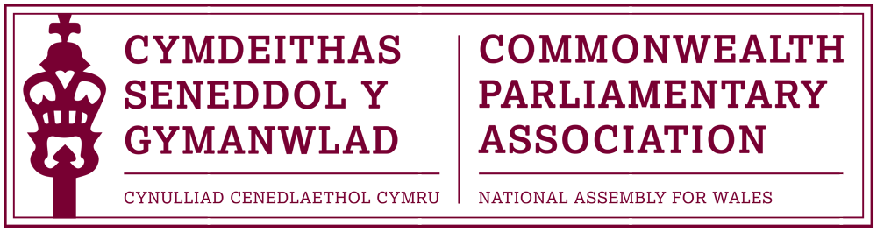

BRANCH EXECUTIVE MEETING

Date: Tuesday 8 March 2016
Time: 08:00
Venue: Dining Room 2, Ty Hywel

AGENDA

- APOLOGIES FOR ABSENCE.

- MINUTES OF THE LAST MEETING – Paper CPA 04-15M (DOC 1)

- MATTERS ARISING FROM MINUTES
- Branch arrangements for transition into 5th Assembly (DOC 2)

- REVIEW OF RECENT ACTIVITIES

Feedback and follow-up of recent Meetings, Visits,
Events and Conferences

- 3rd BIMR CWP Conference (DOC 2)
Guernsey
12-14 February 2016

- Presiding Officer’s Visit to South Africa & Lesotho
12-17 February

5. FORWARD PLANNING

Forthcoming Meetings, Visits, Events and Conferences

- Commonwealth Day Seminar & Observance
Westminster
14 March 2016

- Commonwealth Day Reception
Senedd Oriel
Lunchtime, Tuesday 15 March 2016

- Event with Baroness Scotland
– Secretary General of the Commonwealth
Temple of Peace, Cardiff
Tuesday 22 March

- 13th CPA Canadian Parliamentary Seminar
Ottawa
29 May – 4 June 2016

- 27th Australian Commonwealth Parliamentary Seminar Queensland
5-11 June 2016

- 46th BIMR Conference
St Helia, Jersey
15-18 May 2016

- 62nd Commonwealth Parliamentary Conference
Dhaka, Bangladesh
1-10 September

  - FUTURE MEETING DATES:

Annual General Meeting – May/June 2016 (tbc)

7. NEW ITEMS / ANY OTHER BUSINESS

END OF BUSINESS

