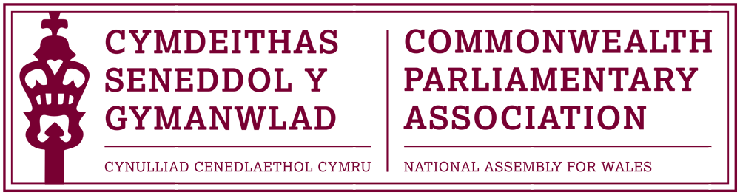

BRANCH EXECUTIVE MEETING

Date: Wednesday 13 July 2016
Time: 12:30
Venue: Dining Room 2, Ty Hywel

AGENDA

- APOLOGIES FOR ABSENCE.

- MINUTES OF THE LAST MEETING
- MATTERS ARISING FROM MINUTES

- REVIEW OF RECENT ACTIVITIES

Feedback and follow-up of recent Meetings, Visits,
Events and Conferences

- Commonwealth Day Reception
Senedd Oriel
Tuesday 15 March 2016

- Event with Baroness Scotland
– Secretary General of the Commonwealth
Temple of Peace, Cardiff
Tuesday 22 March

- 46th BIMR Conference
St Helia, Jersey
15-18 May 2016

5. FORWARD PLANNING

Forthcoming Meetings, Visits, Events and Conferences

2016

- 62nd Commonwealth Parliamentary Conference
Dhaka, Bangladesh
1-10 September

- First Commonwealth Women Leaders’ Summit
London, UK
14 July

- CPA Commonwealth Women Parliamentarians Conference
Kampala, Uganda
8-12 August

- 8th Commonwealth Youth Parliament
British Columbia, Canada
6-10 November

2017

- 4th BIMR CWP Conference
Belfast, Northern Ireland
February (dates tbc)

- 47th CPA (BIM) Regional Conference
Gibraltar
May/June (dates tbc)

  - FUTURE MEETING DATES:

September/October 2016 (tbc)
Opportunity to discuss meeting times of future Branch Meeting.

7. NEW ITEMS / ANY OTHER BUSINESS

END OF BUSINESS

