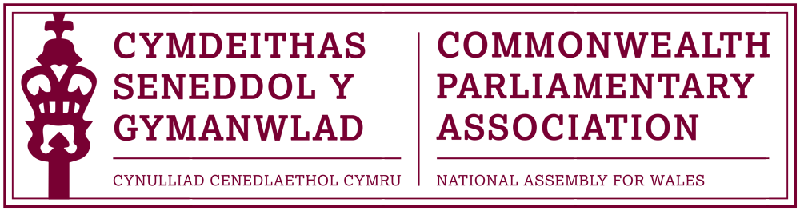

BRANCH EXECUTIVE MEETING

Date: Tuesday 6 December 2016
Time: 12:15
Venue: Dining Room 1, Ty Hywel

AGENDA

- APOLOGIES FOR ABSENCE.

- MINUTES OF THE LAST MEETING - Paper CPA 02-16M (DOC 1)
- MATTERS ARISING FROM MINUTES

- REVIEW OF RECENT ACTIVITIES

Feedback and follow-up of recent Meetings, Visits,
Events and Conferences

- First Commonwealth Women Leaders’ Summit
London, UK (DOC 2)
14 July

- CPA Commonwealth Women Parliamentarians Conference
Kampala, Uganda
8-12 August

- BIMR CWP Steering Committee Meeting (DOC 3)
Senedd, Cardiff
14 October

- 8th Commonwealth Youth Parliament
British Columbia, Canada
6-10 November
- CPA UK & National Assembly of Guyana
Parliamentary Forum on Anti-Corruption
Parliament of Guyana
9-11 November
Guest Speaker: David Melding AM
(Final Item)

5. FORWARD PLANNING

Forthcoming Meetings, Visits, Events and Conferences

2016
- 62nd Commonwealth Parliamentary Conference
London, UK
11-17 December

2017
- 4th BIMR CWP Conference
Belfast, Northern Ireland
3- 5 March

- 47th CPA (BIM) Regional Conference
Gibraltar
21-24 May

- Inaugural Conference for Commonwealth Parliamentarians with Disabilities
Nova Scotia, Canada
August / September (tbc)

  - FUTURE MEETING DATE:
February 2017 (tbc)

7. NEW ITEMS / ANY OTHER BUSINESS

END OF BUSINESS

