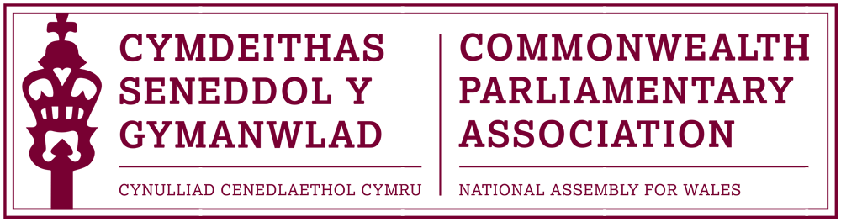

Minutes of the National Assembly for Wales Branch

Annual General Meeting – 28 June 2016

The Presiding Officer and Branch President opened the AGM and, in the absence of a sitting Branch Chair, invited the Branch Secretary, the Assembly’s Chief Executive and Clerk, Claire Clancy to Chair the meeting.

Minutes of Last AGM Meeting held on 30 September 2014

The minutes were accepted as a correct record.

Matters Arising

There were no matters arising.

Report by the CPA Wales Branch Secretary

The Branch Secretary stated that the report which, due to this year’s election, covered activities from June 2014 to March of this year had been circulated with the Agenda. The report includes a record of the Branch’s work and participation during this period and also presented, for our newly elected Members, an insight into the varied opportunities offered to all Assembly Members as part of our membership of the CPA.

Urgent Business

There was no urgent business.

5. Elections to the Branch Executive

Rhun ap Iorwerth AM was nominated by the Plaid Cymru Group; Mohammad Asghar AM was nominated by the Welsh Conservative Group; Rhianon Passmore AM was nominated by the Welsh Labour Group and David Rowlands AM was nominated by the UKIP Wales Group.
The Branch Secretary also confirmed that, following a recent e-election within our British Isles and Mediterranean Region of the CPA, that Joyce Watson AM had been elected to represent the Region as Chair of the Commonwealth Women Parliamentarians for a three year period until 2019. Congratulations and best wishes were offered to Joyce in this important role. Joyce Watson AM was also thanked for her work as Chair of the CPA Wales Branch during the Fourth Assembly.

Chief Executive and Clerk Claire Clancy was elected to serve as Secretary to the Branch with Al Davies, International Relations Team Manager, to continue to oversee the day to day running of the Branch and its meetings as the Acting Branch Secretary.
Rhun ap Iorwerth AM was elected as Branch Chair and was invited to close the meeting. He noted his thanks to Members for the opportunity and of the importance he saw in Wales’ place within the Commonwealth and the wider world.
Rhun ap Iorwerth AM also reminded Members that the minutes of all official Branch meetings and reports would continue to be posted bilingually on the CPA Wales Branch internet pages. Notification of Branch activities, events and all relevant opportunities to attend CPA conferences and seminars would be circulated to all Assembly Members for their consideration as well as being highlighted in the monthly newsletter to Members from the Chief Executive and Clerk.

CPA Wales Branch Secretariat

June 2016

