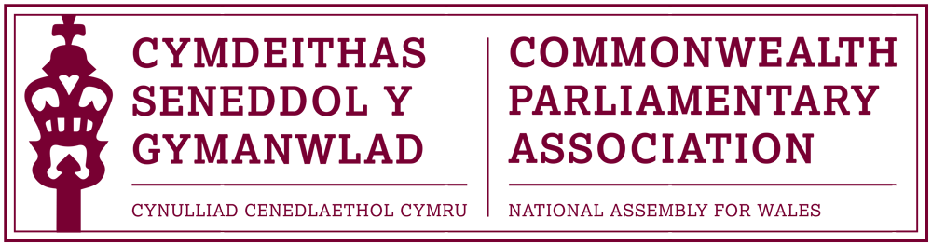

COMMONWEALTH PARLIAMENTARY ASSOCIATION
WALES BRANCH

ANNUAL GENERAL MEETING

Immediately after Plenary on
Tuesday 28 June 2016
in the Siambr

AGENDA

- Minutes of Last Meeting

- Matters Arising

- Report by the National Assembly for Wales Branch Secretary

- Any Urgent Business

- Elections – Branch Chair
Executive Committee Members
Secretary / Acting Secretary

