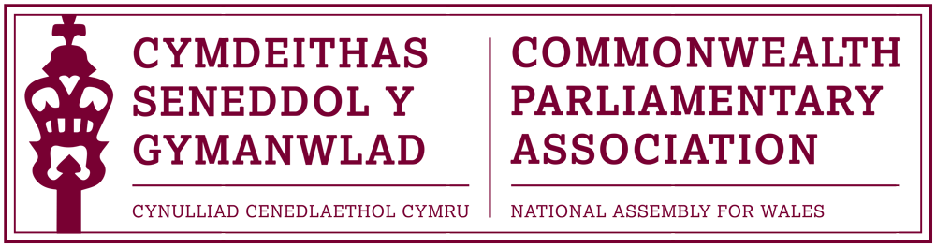

COMMONWEALTH PARLIAMENTARY ASSOCIATION
NATIONAL ASSEMBLY FOR WALES BRANCH EXECUTIVE

REPORT TO THE CPA WALES BRANCH FOR THE PERIOD
7 June 2014 – 8 March 2016

Background
The National Assembly for Wales unanimously agreed a motion signed by the four party leaders to apply for admission to membership of the Commonwealth Parliamentary Association (CPA) on 7 July 1999. Wales was formally welcomed into the CPA at the General Assembly meeting in Trinidad on 19 September 1999.
The Branch Executive meets at least once a term, on the basis that any other Branch Members who wish to be present are also welcome to attend, with prior notification requested if possible.
Branch Structure
All Assembly Members are by default Members of the CPA Wales Branch

Branch Executive Committee
President: Dame Rosemary Butler AM
Vice President: David Melding AM
Chair: Joyce Watson AM
Vice Chairs:
Simon Thomas AM
Mohammad Asghar AM
William Powell AM

Secretary: Claire Clancy,
Chief Executive and Clerk of the National Assembly for Wales
Acting Secretary:
Al Davies, International Relations Team Manager

CHAIR'S REPORT

Due to this year’s Assembly elections and the postponement of the Branch AGM, this report covers a longer than usual period.
During this time the Branch has maintained its position as an active member of the CPA. It has sent delegates to conferences and seminars in the UK and within our British Isles and Mediterranean Region (BIMR) and has hosted a range of visitors from across the Commonwealth to the National Assembly for Wales.

The Commonwealth Women Parliamentarians (CWP) group of our BIMR Region, on which I serve as a Member of the Steering Committee, continues to grow from strength to strength. Janet Haworth AM and I were pleased to last month attend the 3rd CWP Conference, hosted by the Guernsey Branch. I am hopeful that our CPA Branch, with the wealth of experience, expertise and the good story that we have to tell of women’s representation in Wales, will be in a position to host a CWP conference at the Senedd during the Fifth Assembly.

We continue to work effectively with our Education and Youth Engagement team to involve young people in the work of the Assembly and the CPA. The Branch was proud to be represented at last November’s Commonwealth Youth Parliament in Darwin, Australia by Alexandra Atkins and at this year’s Commonwealth Day celebrations in Westminster by Nobee Moyo.

Following the success of our hosting of last year’s British Isles and Mediterranean Regional Conference – without a doubt one of the highlights for our Branch during this Fourth Assembly – it was a pleasure last May to field a full delegation, led by Branch Vice-President David Melding AM, to attend the 45th BIMR Conference hosted by the CPA Cyprus Branch.

The CPA Wales Branch Executive Committee held seven formal meetings during the period of this report. The minutes from these meetings, as well as all reports submitted by Branch Members are available bilingually on the CPA pages of the National Assembly’s website. The Branch’s reports webpage can be accessed by clicking here

As this is my last report of this term as Branch Chair, may I take this opportunity to thank Members for their interest and participation in the work of our Branch during this Fourth Assembly. The next Branch Annual General Meeting will take place as soon as is practical, following the forthcoming Assembly elections. I hope that those of you who return to the Assembly continue to engage with and take advantages of the opportunities presented by our membership of the CPA, and that you also encourage those Members newly elected to the Assembly to do the same.
Joyce Watson AM.
CPA Wales Branch Chair.

ACTIVITIES UNDERTAKEN DURING THE PERIOD OF THE REPORT:

BIMR CWP Steering Committee Meeting (December 2014)
The Meeting was attended by Branch Chair and Joyce Watson AM.

2nd Conference of the Commonwealth Women Parliamentarians (CWP) from the British Isles and Mediterranean Region (BIMR), Gibraltar (February 2015)
Branch Chair and Steering Committee Representative Joyce Watson AM attended the 2nd BIMR CWP Conference, accompanied by Ann Jones AM and Jenny Rathbone AM. The theme of the conference was “The Role of Parliamentarians in Ending Violence against Women”.

Commonwealth Day 2015 (March 2015)
Commonwealth Day was marked with the Assembly hosting an evening reception in partnership with the British Council Wales.

The Theme of this year’s Commonwealth Day was “A Young Commonwealth” and the Branch was represented at the official Commonwealth Day celebrations in Westminster by two young people – James Jones and Esther Jones from Ysgol Dyffryn Aman with whom the Assembly’s CPA Branch had been working, as part of the 2014 BIMR Conference we hosted.

Report

45th Conference of the British Isles and Mediterranean Region (BIMR) Limassol, Cyprus (May 2015).
The CPA Wales branch was represented at the Annual Regional Conference by Branch Vice-President David Melding AM, Chair Joyce Watson AM, Executive Committee Member Simon Thomas AM and Ann Jones AM. The conference theme was “Parliaments in the Face of Contemporary Challenges”

Report

BIMR CWP Steering Committee Meeting (October 2015)
The Meeting was attended by Branch Chair Joyce Watson AM

7th Commonwealth Youth Parliament (CYP)
Darwin, Australia (November 2015)

Following interviews and selection by the Branch Executive Committee, the Branch was represented at the 7th CYP in Australia by successful applicant Alexandra Atkins.

Report

Commonwealth Women’s Forum, Malta (November 2015)
Branch President Dame Rosemary Butler AM and Branch Chair Joyce Watson AM attended this inaugural Women’s Forum, the theme of which was “Women Ahead – Be all that You Can Be”.
The Conference formed part of the wider biennial Commonwealth Heads of Government (CHOGM) Meeting, hosted by Malta.

3rd Conference of the Commonwealth Women Parliamentarians (CWP) from the British Isles and Mediterranean Region (BIMR), Guernsey (February 2016)
Branch Chair and Steering Committee Representative Joyce Watson AM attended the 3rd BIMR CWP Conference, accompanied by Janet Haworth AM. The theme of the conference was “Influencing Policies & Legislation for the Empowerment of Women”.

Visit to South Africa & Lesotho (February 2016)
Branch President, Dame Rosemary Butler AM, undertook a short visit to Africa. The Programme included visits and meetings with The British Council in South Africa, the Gauteng Provincial Parliament in Johannesburg, the Speakers of both the Lesotho Senate and National Assembly, the Welsh Schoolteachers currently teaching in Lesotho as well as South Africa’s Federal Parliament and Members of the Welsh community living in South Africa.
A report of the visit will follow.

Commonwealth Visitors to the Senedd.
The Branch has assisted in the development of programmes for international visitors to the Assembly included Speakers, High Commissioners and delegations from Fiji, Canada, Australia and Gibraltar

Branch Sponsorship Scheme (on-going).
Members are reminded of this scheme and encouraged to look for opportunities to apply for support for study visits to other Commonwealth Parliaments and Assemblies. Members interested in this opportunity should in the first instance email the Acting Branch Secretary Al Davies (al.davies@assembly.wales) with a brief outline and business case of their proposed study visit.

Forward Look:

Branch AGM
Late May / Early June 2016 (tbc)

46th BIMR Conference, Jersey
15-18 May 2016

62nd Commonwealth Parliamentary Conference - Dhaka, Bangladesh
1-10 September 2016

8th Commonwealth Youth Parliament - British Columbia, Canada
October/November 2016

4th BIMR CWP, Belfast, Northern Ireland
February 2017

March 2016

