Key Findings of Girl Guides Survey
Introduction
Girlguiding Cymru were asked by the Expert Panel to provide evidence on young people’s views on the minimum voting age.
It carried out a survey of its senior section members (primarily aged between 15 and 25) to gather their opinions on this. In total, 53 people responded. The below note has been prepared by the Panel secretariat to summarise the responses.
Age
Overall, the group expressed a view in favour of lowering the voting age, with 68% (36 of the 53) agreeing with this.
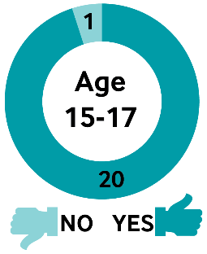
Of those surveyed who were aged 15-17, all but one responder said they were in favour in lowering the voting age (with 20 out of 21 in favour).
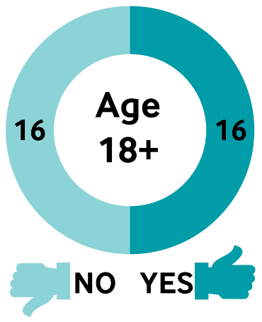

Of those aged 18 and over (18-58), there was more of a mixed reaction to this question, with an even split in favour and opposed (16 out of 32 in favour).

Girl Guide Counties
When broken down by Girl Guide Counties (which are explained in the map below), there does not appear to be any clear trend in terms of response. It is also worth noting that number of participants from each area varied, and that the sample was self-selecting.

Map key | County and total respondents | Yes | No
10 | Breconshire (1) | 1 | 0
3 | Caernarfonshire (3) | 1 | 2
14 | Cardiff and East Glamorgan (12) | 8 | 4
9 | Carmarthenshire (5) | 5 | 0
12 | Central Glamorgan (7) | 5 | 2
6 | Ceredigion (4) | 3 | 1
2 | Clwyd (5) | 4 | 1
13 | Gwent (8) | 4 | 4
4 | Merioneth(1) | 1 | 0
5 | Montgomeryshire (1) | 0 | 1
8 | Pembrokeshire (3) | 3 | 0
11 | West Glamorgan (3) | 1 | 2
Map source: Girl guiding Cymru Website

Comments
Many of the comments from the under 18 section surveyed were focused on the fact that voting would impact on their future as well as those of current voting age:
“I believe that without the right to vote, my future has been chosen for me, regardless of my opinion. The younger generation should have the right to choose our future and have our voices heard.”
“I would like to decide my own future rather than putting it into the hands of the older demographic. Realistically, 16/17 year olds are the future of this country and so we should have a say in what policies make it into Parliament etc.”
“It's our future- we are mature enough to make our decisions.”
“I had to watch an older population vote for a future they won't even see. It wasn't fair.”
“It is frustrating having others decide my future for me as I have no say.”
Of those who were not in favour of a lower voting age, some of the reasons why included believing that the government should be focused instead on better informing those currently of voting age:
“I believe that the Government should concentrate on getting more 18-25 year olds to understand politics and voting to start off with in my opinion.”
“Being disengaged is a problem with 18-20 year olds who CAN vote. 16 and 17 would be low also.”
“Young people are far more likely to accept what they see on social media and allow it to sway their vote than young people over 18.”
“I think 18 is appropriate to vote.”
A small group of the participants commented that they felt that 16-18 year olds should not be able to vote in general and local elections, but should be able to vote in a referendum.
There were many responses to the question: “Are there other ways to help you or other young people become more interested in politics or more likely to vote?” with 96% of those surveyed (52 out of 54) commenting on this.
Most were focused on improving political awareness of young people, with half of responders (27 of 54) specifically mentioning school-based discussions or learning, such as:
“Include politics in schools, for example hold mock referendums/elections within the school, have political debates in schools, start a newspaper aimed at young people to get students to be more aware of politics and how it affects them.”
“We need more information, talks at schools, college or university. So that we know what is going on.”
“Active participation in politics during an election period within school would encourage younger people even further (mock elections, discussions of what the parties stand for).”
“Educating young people at school or at youth groups would give young people a better understanding of what they are voting for and how the voting system works.”
“Teach them in school. I had zero teaching about modern day politics during school. It is an educational, interesting (if taught in the right way) and influential topic.”
“Teaching about politics in schools, making it accessible, understandable and interesting.”
Other comments in response to this question included simplifying manifestos for a younger audience, promoting television shows relating to politics, and making use of social media to highlight issues.
Are few examples are below:
“Manifestos could be anchored towards young people”
“More information being passed on in language we will understand.”
“Make it young-person friendly by interviewing younger people”
“More TV shows / YouTube videos targeted at young people about politics.”
“Simplified versions of manifestos as very few young people understand political terms. It should also be made a little more fun.”
“Get politicians to try and appeal to younger people.”
“Use of social media to educate.”

