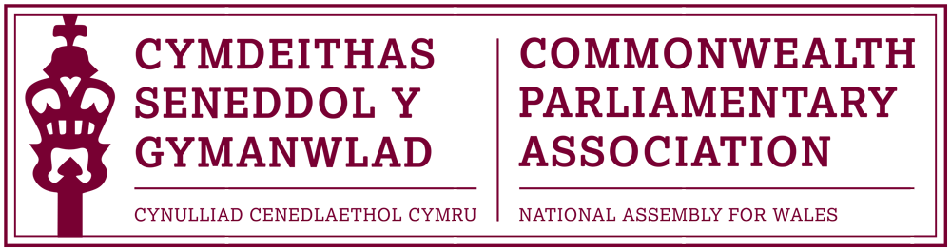

BRANCH EXECUTIVE MEETING

Date: Wednesday 22 March 2017
Time: 12:30
Venue: Meeting Room 16 (Senedd)

AGENDA

- APOLOGIES FOR ABSENCE.

- MINUTES OF THE LAST MEETING - Paper CPA 03-16M (DOC 1)
- MATTERS ARISING FROM MINUTES

- REVIEW OF RECENT ACTIVITIES

Feedback and follow-up of recent Meetings, Visits,
Events and Conferences

2016

- 62nd Commonwealth Parliamentary Conference
London, UK (DOC2)
11-17 December 2016

- Laura Elliott (Branch Participant at CYP) meeting with Branch
Chair and President
18 January 2017

Commonwealth Women Parliamentarians -
Working Group Meeting - Wilton Park, UK
24-27 February 2017

2017

- Québec’s Agent-General in London – Christos Sirros
Senedd
8 March

- Commonwealth Day Programme
Westminster, London
13 March

5. FORWARD PLANNING

Forthcoming Meetings, Visits, Events and Conferences

- 4th BIMR CWP Conference – Draft Programme (DOC 5)
National Assembly for Wales
6-8 April

- CPA Fundamentals Programme
Montreal, Quebec (Canada)
23-30 April

- 47th CPA (BIM) Regional Conference
Gibraltar
21-24 May

- Inaugural Conference for Commonwealth Parliamentarians
with Disabilities
Nova Scotia, Canada
30 August – 2 September (tbc)

- 63rd Commonwealth Parliamentary Conference (CPC)
Dhaka, Bangladesh
Dates TBC

  - FUTURE MEETING DATE(s):

Branch Executive Committee Meeting – May
Annual General Meeting – June/July

7. NEW ITEMS / ANY OTHER BUSINESS

Papers to note:
i) 8th Commonwealth Youth Parliament - Report by Laura Elliott
(DOC 3)
ii) Report of CPA UK and National Assembly of Guyana Parliamentary
Forum on Anti-Corruption (DOC 4)

- Appointment of New Private Office Manager
(International & Communications)

END OF BUSINESS

