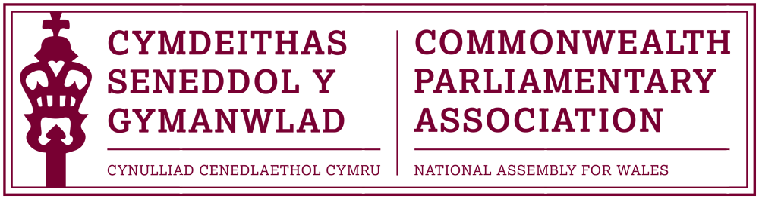

BRANCH EXECUTIVE MEETING

Date: Wednesday 12 July 2017
Time: 12:15
Venue: Video Conference Room (1st Floor, Ty Hywel)

AGENDA

- APOLOGIES FOR ABSENCE.

- MINUTES OF THE LAST MEETING - Paper CPA 01-17M (DOC 1)
- MATTERS ARISING FROM MINUTES

- REVIEW OF RECENT ACTIVITIES

Feedback and follow-up of recent Meetings, Visits,
Events and Conferences
2017

- 4th BIMR CWP Conference (DOC 2)
National Assembly for Wales
6-7 April

- CPA Mid-Year Executive Committee Meeting
Darwin, (NT) Australia
25-28 April

- CPA Fundamentals Programme
Montreal, Quebec (Canada)
23-30 April

- Cayman Islands Election Observer Mission
18-28 May

- 47th CPA (BIM) Regional Conference
Gibraltar
21-24 May

- CPA UK Modern Slavery Project Africa Region Workshop
Uganda
4-6 July

5. FORWARD PLANNING

Forthcoming Meetings, Visits, Events and Conferences

2017

- Inaugural CPA Conference for Parliamentarians with Disabilities
Nova Scotia, Canada
30 August – 2 September

- Participation in CPA Training Programme for New Parliamentarians at the Parliament of The Gambia
Banjul
September (TBC)

- 9th Commonwealth Youth Parliament
(British) Virgin Islands
9-13 October

- 14th Canadian Parliamentary Seminar (DOC 3)
Ottawa
15-21 October

- 63rd Commonwealth Parliamentary Conference (CPC)
Dhaka, Bangladesh
1-8 November

- Visit of the CPA Secretary General to Wales
Dates to be confirmed

  - FUTURE MEETING DATES:

      - Interviews for 9th CYP Shortlisted Candidates – 20 July
      - Annual General Meeting – September (TBC)
      - Branch Executive Committee Meeting – October (TBC)

7. NEW ITEMS / ANY OTHER BUSINESS

      - Participation in CPA Election Observer Missions

END OF BUSINESS

