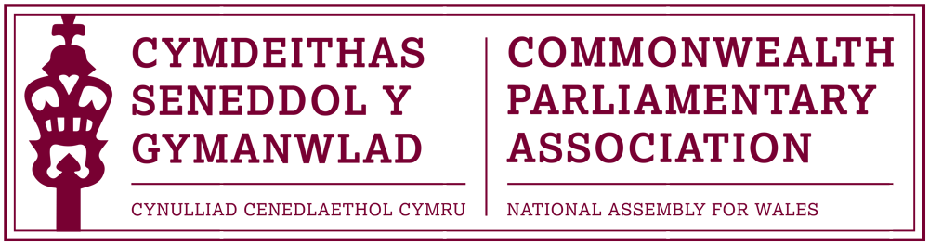

BRANCH EXECUTIVE MEETING

Date: Tuesday 9 July 2019
Time: 12:15
Venue: Dining Room 1 (1st Floor, Ty Hywel)

AGENDA

- APOLOGIES FOR ABSENCE.

- MINUTES OF THE LAST MEETING - Paper CPA 01-19M (DOC 1)
- MATTERS ARISING FROM MINUTES
- REVIEW OF RECENT ACTIVITIES

Feedback and follow-up of recent Meetings, Visits,
Events and Conferences
- 48th BIM Regional Conference
Guernsey
19-22 May 2019 (AGM Minutes attached – DOC 3)

- BIMR CWP Outreach Programme
Nicosia, Cyprus
13-14 June 2019

- Westminster Workshop on Gender Sensitive Scrutiny
London
17-19 June 2019

5. FORWARD PLANNING

Forthcoming Meetings, Visits, Events and Conferences

- CPA Caribbean Regional Conference
Trinidad
15-18 July 2019

- CPA Election Observer Mission Training
Westminster
18-19 July 2019
- 6th BIMR CWP Conference
Jersey
19-20 September 2019 (DOC 2)

- 2019 Commonwealth Parliamentary Conference
Kampala, Uganda
22-28 September 2019

- Gambia Parliament Standing Orders workshop outward programme
2-4 October 2019

- BIMR CWP Conference
Falkland Islands - February 2020 (tbc)

  - FUTURE MEETING DATES:
      - Branch Executive Meeting – October (TBC)
      - BEC Meetings to discuss new draft Branch rules

7. NEW ITEMS / ANY OTHER BUSINESS
- CPA Wales Commonwealth Women Parliamentarians (CWP)
Representative.

      - Paper to note:
Llywydd and Branch Chair Africa Visit report (DOC 4)

END OF BUSINESS

