9th British Islands and Mediterranean Region Commonwealth Women Parliamentarians’ Conference, Gibraltar, 4-6 October 2022
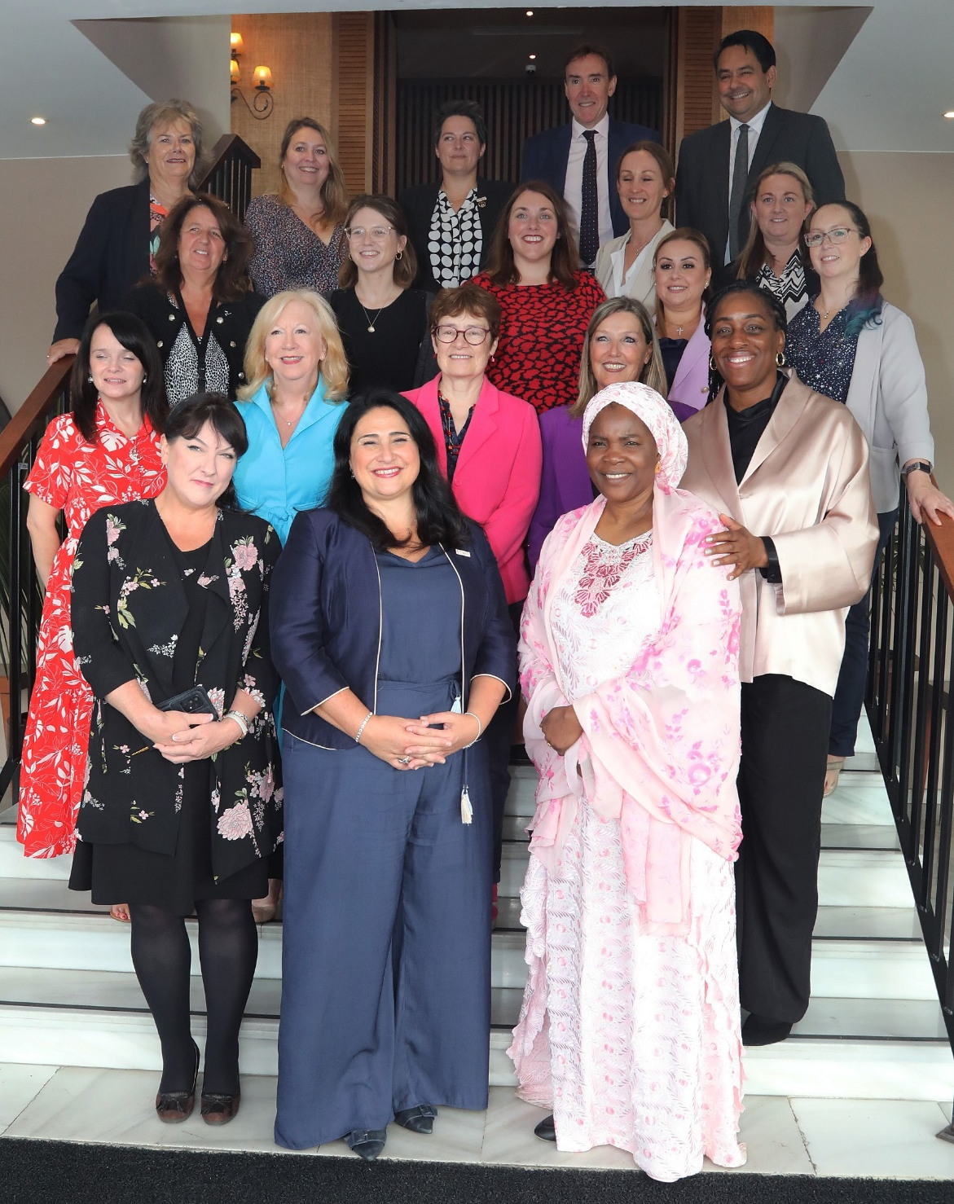

Report
Introduction
Members of Parliament from across the CPA British Islands and Mediterranean Region (UK, Scotland, Wales, Isle of Man, Jersey, Guernsey, Gibraltar & Malta) participated in the 9th BIMR Commonwealth Women Parliamentarians Conference, delivered jointly by CPA Gibraltar and the CPA British Islands and Mediterranean Region Secretariat, on 5 & 6 October 2022.

With the overall aim of “Attracting and Retaining Effective Women Parliamentarians”, and building on ongoing engagement, the Conference focused on various aspects of this in more detail.

Delegates explored how parliaments across the region are responding to the escalating problem of online harms. The programme included tailored practical training for women parliamentarians on digital self-defence, digital citizenship, assertive communication, and safety responses to online abuse. It also looked at the UK’s draft ‘Online Harms Bill’ and the lessons learned from the UK’s legislative pathway to protect against online harms.

The programme also included sessions focusing on Gender Sensitive Parliaments, asking if parliaments are doing enough to respond to the changing demographics of their elected representatives. Delegates considered the recommendations made by Dr Jess Smith (University of Southampton) in her report Effective and Inclusive Parliaments.

CPA UK gathered both formal and informal feedback throughout the Conference. Highlights for delegates included hearing from experts on legislating against online harms, the opportunity to discuss measures to support parliamentarians with caring responsibilities and the outreach activity promoting political pathways to women in Gibraltar.

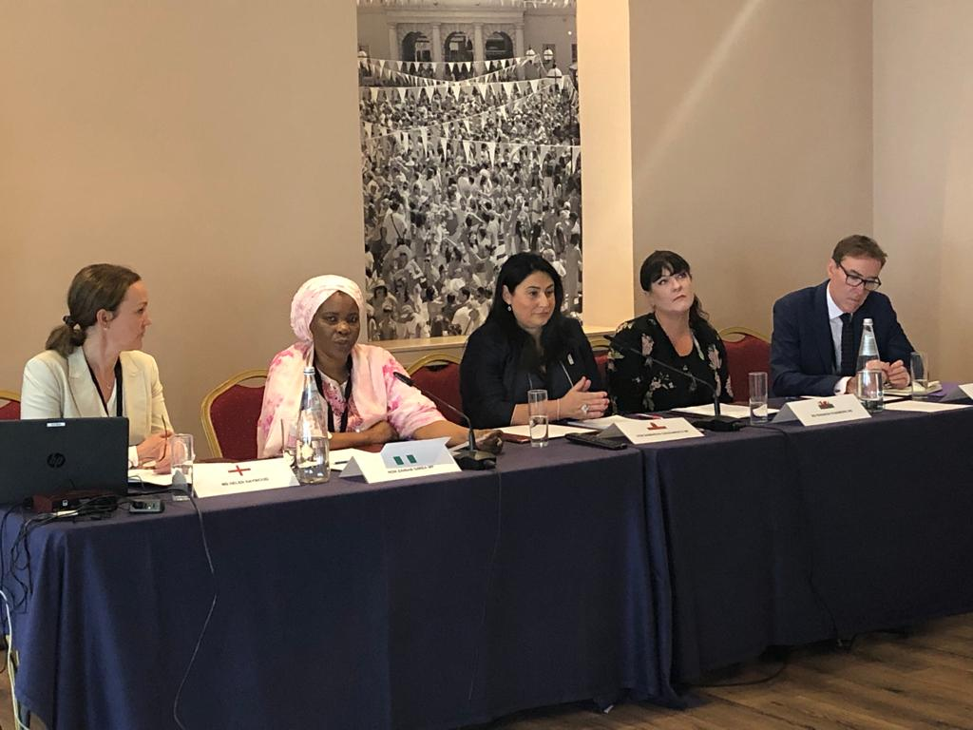
Delegates
Gibraltar
Hon. Samantha Sacramento MP (Member, BIMR CWP Steering Committee)
Hon. Marlene Hassan-Nahon MP
Guernsey
Deputy Susan Aldwell
Emma Atkinson – Delegation Secretary

Isle of Man
Ann Corlett MHK
Jersey
Deputy Louise Doublet
Deputy Lucy Stephenson
Vanessa Page – Delegation Secretary
Malta
Hon. Davina Sammut Hili MP
Hon. Graziella Attard Previ, MP
Scotland
Sarah Boyack MSP (Member, BIMR CWP Steering Committee)
Charlotta Norlander – Delegation Secretary
Wales
Heledd Fychan MS
Rhianon Passmore MS (Deputy Chair, BIMR CWP Steering Committee)
Buffy Williams MS
Enfys Roberts – Delegation Secretary
UK
Rt Hon. Dame Eleanor Laing MP
Rt Hon. Karen Bradley MP
Kate Osamor MP
Jon Davies – Secretary, CPA British Islands and Mediterranean Region / CPA UK
Helen Haywood – Secretary to the BIMR CWP Steering Committee / CPA UK
Amy Knox – CPA UK

Official Guests:
Hon. Zainab Gimba MP (Nigeria) – Chair, Commonwealth Women Parliamentarians
Stephen Twigg – CPA Secretary-General
Bénite Dibateza – CPA Secretariat

Legislating on Online Safety
This session explored how parliamentarians can effectively legislate against online harms. It considered how parliamentarians can apply gender-sensitive scrutiny to ensure legislation effectively reflects and addresses the experiences of women online. The UK Government’s Online Safety Bill was used as a case study.
Professor Penney Lewis, Criminal Law Commissioner of the UK Law Commission discussed the background to the Law Commission’s reform of the Communications Project, commissioned by the Department for Culture, Digital Media and Sport. The project aimed to explore legislative pathways to address existing inadequacies within communications offences in the UK, namely their ineffectiveness in criminalising genuinely harmful behaviour with the advent of social media, while disproportionately interfering with freedom of expression in other areas.
Professor Lewis outlined the Commission’s key recommendations for the UK Government’s Online Safety Bill to replace existing offences, including: a general harms-based offence; knowingly sending false communications intending harm; sending threats of serious harm; intentionally encouraging or assisting serious self-harm; and cyber-flashing.
Professor Lewis outlined various key lessons for jurisdictions looking to reform their communications offences, namely the importance of creating an offence which reflects that harmful communications are varied, context specific and are difficult to categorise. In addition, it was recommended that parliamentarians consider the culpability of the defendant to be equally as important in setting the boundaries of criminal law, rather than just focusing on the harm to the victim. Finally, delegates were advised that the more general the range of communications in scope, the greater the need for a specific element in legislation addressing freedom of expression rights.
Further links and resources:
- Reform of the Communications Offences Project
- Modernisation of the Communication Offences: A Final Report
Dr Kim Barker, Senior Lecturer in Law, Open University outlined the key principles underpinning good practices in legislating against online harms, including the provisions legislation should include. A foundational principle was for legislation to be gender-sensitive in its approach, to reflect that women’s and men’s experiences of the online space differ, and that women are disproportionately impacted by gender-based violence online. Dr Barker recommended a holistic approach, encompassing criminal and civil legal frameworks, as well as prevention initiatives, to address the range of harms women face online effectively and comprehensively.
Dr Barker highlighted the need for legislation to:
- Be guided by a clear definition of online violence against women which recognises online harm as a form of gender-based violence
- Be formed in consultation with key stakeholders who are either affected by or will be responsible for the implementation of legislation
- Mandate platform accountability by compelling platforms to develop corporate policies, practices and tools that respect women’s rights and counter online practices that are harmful to women
- Empower regulators to provide swift solutions in cooperation with private sector platforms
- Be victim/survivor-orientated in its approach and therefore prioritising forms of swift redress such as takedown protocols
- Build capacity of actors responsible for implementation of legislation by mandating sensitivity training around all forms of online violence against women, and how those experiences map onto legally recognised categories of wrongdoing, would help to prevent inaction and mitigate harm
Dr Barker described the UK’s Online Safety Bill as a useful starting point with merit in its broad ambition and demonstrative of strength in uniting stakeholders to address the issue. However, Dr Barker expressed concern that the Bill falls short of its potential in protecting women from online harm, most notably due to the absence of women and girls as a priority, and its lack of recognition of online harm as a form of gender-based violence.
Further links and resources:
- Online Harms White Paper Consultation Response
- Online Violence Against Women: addressing the responsibility gap?
- Written evidence submitted by Dr Kim Barker and Dr Olga Jurasz, Open University Law School
- CPA UK Report: Gender-Sensitive Responses to Online Harms
Kate Osamor MP, UK Parliament provided an overview of the UK Government’s Online Safety Bill and its journey through parliament. The Online Safety Bill was introduced in April 2022 and has so far reached report stage in the House of Commons.
The Government has said the Bill delivers its “manifesto commitment to make the UK the safest place in the world to be online while defending free expression”. The Bill has five policy objectives:
- to increase user safety online.
- to preserve and enhance freedom of speech online.
- to improve law enforcement’s ability to tackle illegal content online.
- to improve users’ ability to keep themselves safe online.
- to improve society’s understanding of the harm landscape.

Early drafts of the bill were considered overly complex and gave too much freedom to tech companies to continue to write their own rules. Changes were made by the Government in response to parliamentary scrutiny of the draft Bill, but there remain claims by stakeholders that the Bill “remains too complex”.

Kate Osamor MP discussed the key parliamentary campaign which has emerged in opposition to the Bill, concerning the Bill’s perceived weaknesses around promoting platform accountability and its inability to effectively challenge the business models of large companies. The UK Labour Party has described the legislation as ‘watered down’ and argued that they would strengthen the Bill by including criminal sanctions for senior tech executives who repeatedly fail to enforce the rules and provide greater teeth to regulators.

Kate Osamor MP also discussed criticisms of the Bill’s gender-sensitivity in its current form. Opposition parties and other stakeholders have argued that the Bill presents a gender-neutral solution to a gendered problem. Refuge, Glitch and the End Violence Against Women Coalition have been advocating for women to be named on the Bill, as well as the incorporation of the range of harms women face online.
- Analysis of the Online Safety Bill, House of Commons Library
- Online Safety Bill: Commons stages, House of Commons Library
- Joint Committee on the Draft Online Safety Bill, Report of Session 2021–22
- VAGW Principles for the Online Safety Bill, End Violence Against Women

Emma Pickering, Senior Operations Manager, Tech and Economic Abuse, Refuge discussed Refuge’s work around technology-facilitated violence against women, including the establishment of the UK’s first dedicated Tech Safety Service supporting victim/survivors of complex tech abuse with a range of specialised services. The launch of this service resulted from Refuge experiencing a 97% increase in the number of complex tech abuse cases between April 2020 and May 2021. The service was created in partnership with survivors and offers each referral a dedicated Tech Advocate to provide support and empower survivors.
Emma Pickering shared that Complex tech abuse cases often involve perpetrators using multiple accounts and devices to abuse, control and monitor their partners. The technology harnessed can range from everyday devices and accounts, to sophisticated, malicious software. A recent report from one of Refuge’s digital security partners Avast found a 93% increase in the use of malicious stalker-ware and spyware apps when compared to the same time last year.
- Unsocial Spaces, Refuge
- Marked as Unsafe, Refuge

Parliamentary Management of Online Safety
This session explored how parliaments can manage the online safety of members and protect women MPs from the potential harms they face online, using the UK Parliament’s Social Media Monitoring Service as a case study.
In recent years, the incidents of criminal abuse and harassment suffered by MPs have risen sharply and both the House of Commons and the police services have increased security arrangements and taken more legal action as a result. Oliver Davis, Head of the UK Parliament’s Security Information and Risk Analysis Service and Ezgi Payir from the Social Media Safety Team outlined the role of the Parliamentary Social Media Monitoring Service and how it operates. Members of the House of Commons and House of Lords can sign up voluntarily and consent to have their social media channels monitored for online abuse, using software in collaboration with social media companies. The social media monitoring service also involves forwarding threatening or abusive social media communications to the Police. There are currently 237 Members who have opted into the social media monitoring service.
Further links and resources:
- Democracy, freedom of expression and freedom of association: Threats to MPs, Joint Committee on Human Rights
- Intimidation in Public Life, A Review by the Committee on Standards in Public Life
- UK Parliament Social Media Monitoring Service

Workshop on Managing Online Abuse
CPA UK’s Amy Knox facilitated a workshop delivered by UK Charity Glitch exploring the impact of online abuse on women parliamentarians, aiming to equip delegates with the skills and tools necessary to defend themselves online and build resilience against online harms.
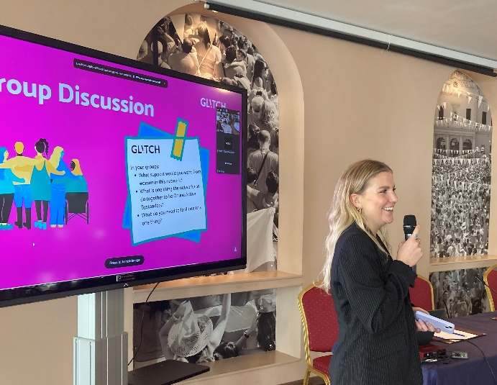
Further links and resources:
- Glitch Resources

- Think10 Safety Questionnaire, National Democratic Institute

- Guide on Managing Online and Offline Abuse, CPA UK

Effective and Inclusive Parliaments
This session, led by Dr Jessica Smith, explored the findings from the Report on Effective and Inclusive Parliaments in the BIMR, focusing on hybridity and related parliamentary infrastructure promoting gender-sensitivity.
Dr Jessica Smith’s findings revealed that most parliaments in the region are falling short of meeting gender-sensitive benchmarks including on diversity of MPs, women’s leadership positions, childcare and child-friendly provisions and maternity and parental leave.
Delegates discussed the recommendations made by Dr Smith concerning hybridity and parental leave. Delegates considered how they could be applied to different BIMR parliaments respectively, including virtual participation and proxy voting. Delegates also agreed that such provisions should extend not only to mothers but all care providers and other minority groups who may be systematically excluded by the existing systems.
Delegates further agreed that the application of recommendations were context specific and practices which work well in some parliaments may be less applicable in others. For example, Wales was cited as an example where hybridity has remained in place following COVID-19 and is working well, while this was considered to be less feasible in the UK context due to the setup of the chamber. Upcoming research by Dr Smith will further discuss whether constituents are less likely to vote for members who attend parliament in a hybrid manner or who take parental leave.
Further links and resources:
- Report on Effective and Inclusive Parliaments in the BIMR
- CPA Gender Sensitising Parliaments Guidelines

Equality Reviews in BIMR Parliaments
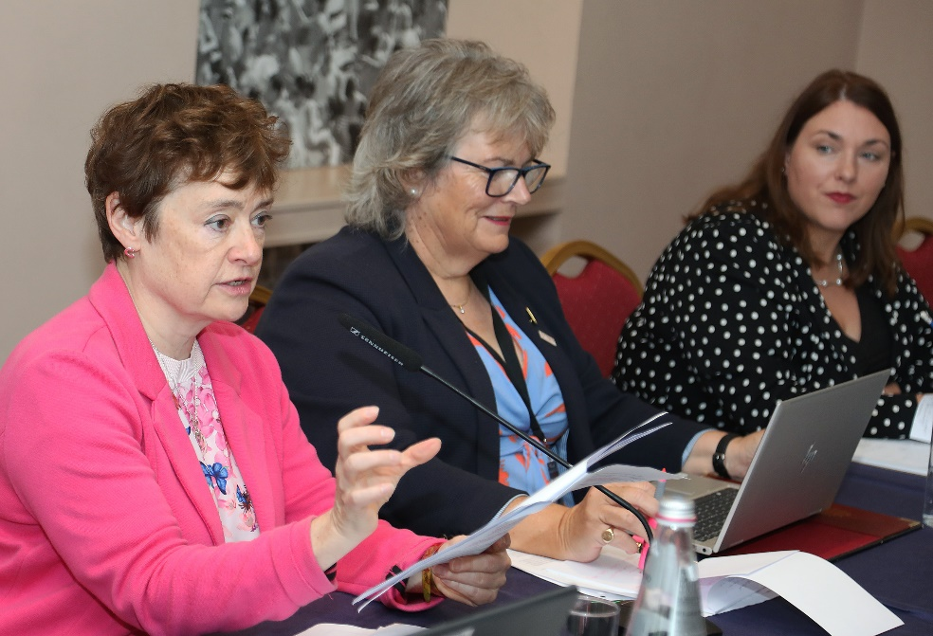
Sarah Boyack MSP outlined Scottish Parliament’s Gender Sensitive Parliament Audit, which aimed to review the representation and participation of women in the Scottish Parliament. The Audit was supported by the establishment of an Audit group, consisting of all parties represented in Holyrood, as well as staffers, academics, and Engender. The audit’s remit included the number and position of women parliamentarians, participation and intervention levels in Chamber business and the impact of parliamentary procedures and policies. The Audit is scheduled to reach reporting stage by the end of 2022.

Sarah Boyack reported that engagement of civil society was key to establishing and implementing the audit. Engender, Scotland’s feminist policy and advocacy organisation, are an instrumental member of the Audit group, bringing a range of expertise and resources.

Further links and resources:

- Sex & Power in Scotland in 2020, Engender

Heledd Fychan MS discussed the background to the Senedd reform programme, which aimed to promote changes to strengthen the role of the Senedd to better suit the needs of the people of Wales. The Expert Panel on Assembly Electoral Reform was established in February 2017 to advise the Llywydd (Speaker) and Senedd Commission on a range of potential reforms, such as the number of Members the Senedd needs, the most suitable electoral system by which they should be elected, issues relating to Senedd electoral areas and the minimum voting age for Senedd elections. The reform work was split into two phases. Phase 1, led to Senedd and Elections (Wales) Act 2020 and Phase 2 was intended ‘to make the Senedd a more effective, accessible and diverse legislature’.

Heledd Fychan shared that due to parliamentary time constrains, in 2019 the Senedd Commission decided to establish a Committee on Senedd Electoral Reform as it would not be possible to legislate on Phase 2 during the current Senedd. The Committee found ‘clear and compelling’ evidence that the Senedd is currently undersized and that its membership lacks diversity. The Committee made 32 recommendations, including actions to achieve a gender equal Senedd with representatives from diverse backgrounds. Key recommendations included the implementation of a gender quota integrated within the electoral system, strengthening candidate-based selection processes to support a gender equal parliament and enabling candidates to stand for election on the basis of job-sharing arrangements.

Heledd Fychan reported that the Welsh Government is aiming to have the changes in place by 2023 and will therefore need to bring a Bill to parliament next year for this to be delivered.

Further links and resources:

- Senedd reform: the next steps
- Reforming our Senedd: A stronger voice for the people of Wales

Workshop on Mechanisms to Support Parliamentarians with Caring Responsibilities

This session focused on how parliaments have dealt with the issue of parental leave, cover and proxy voting. It considered how each parliament has implemented infrastructural support for parents and parliamentarians with other caring responsibilities such as childcare facilities, babies in the chamber, hybrid working and family-friendly hours.

- In the UK Parliament, proxy voting is available for MPs on baby leave and has been extended to MPs with long-term illnesses, however it is not available for MPs with other caring responsibilities. While childcare facilities are available onsite, babies in the chamber are subject to debate and has been considered by the Procedure Committee, who concluded babies should not be present during proceedings.
- In the Senedd, proxy voting is available to those on parental leave, of which men can also take advantage. Delegates reported an increasing demand for childcare facilities which were not provided in the new parliament building.
- In the Scottish Parliament, the Standards Committee is currently considering extending COVID-19 provisions for hybrid working and piloting a proxy voting scheme for those with childcare responsibilities and illness.
- In the States Assembly of Jersey, there are currently no provisions in place and a ‘gold plated’ reason for absence is required for proxy voting. The hybrid provisions from COVID-19 remain in place for positive cases and long-term illnesses, but do not extend to childcare. Delegates reported an increasing demand for formal provisions and family friendlier hours.
- Delegates from Guernsey, Isle of Man, Cyprus and Malta reported there are no provisions in place, however this has been requested by a growing number of younger women parliamentarians elected.

Session Chair Dame Eleanor Laing asked break-out groups to identify their top three reforms they would like to see implemented to make parliaments more attractive to a more diverse cohort of prospective candidates. These were:

Group 1:
1. Provision for wraparound care
2. Onsite creche
3. Hybrid participation options

Group 2:
1. Find a Champion in Parliamentary Leadership
2. Financial Support (i.e., extra staffing budget/accommodation/childcare)
3. Educate the public about the need for more women/GSPs (so less backlash on extra costs)

Group 3:
1. Provision for parliamentary visitors i.e., a creche, to ensure equal participation in democracy
2. Hybrid participation and remote voting
3. Predictability of the legislature/regular hours

Elections in the BIMR

The Session considered case-studies from two branches in the region which have had elections in 2022 – Jersey and Malta - to look at the outcomes in respect to gender representation. Key areas of interest were the introduction of a new gender quota mechanism in Malta, and the increase in women’s representation in Jersey from 29% (2019) to 43% (2022).
Hon. Graziella Attard Previ MP outlined the context and process of constitutional reform which led to the introduction of gender quotas in Malta. The reform was driven by alarming statistic that in the previous parliament only 9 of Malta’s 67 parliamentarians were women, the second lowest representation in Europe. The Maltese constitution was amended to allocate 12 additional parliamentary seats for women if they do not gain a 40 percent share in elections (and for 20 years afterwards). Hon. Graziella Attard Previ MP shared that the reforms had broad support from key stakeholders, including the National Commission for the Promotion of Equality.
Following the quota’s implementation in January and the proceeding election in April, 22 MPs were elected now constituting 27.8% of parliamentarians. The quota was therefore successful in its purported aims of increasing women’s representation; although has faced criticisms on account of its limitations in addressing the systemic structural and cultural barriers to the representation of women in parliament and their participation in political life, including pervasive gender stereotypes and a male-dominated political sphere.
The Application of Gender Quotas in Malta, Equality Law EU
Deputy Lucy Stephenson outlined the context of gender representation in Jersey, which has historically been low. Since 1948, 344 men have sat in the States Assembly, while only 45 women have done so. However, the 2022 election saw more women elected to Jersey's government than ever before, forming 43% of the States Assembly. More than 50% of the deputies elected were women.
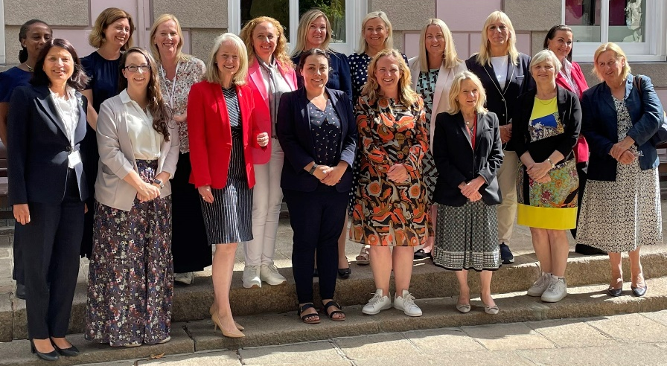
The gains in elected women Deputies were achieved despite the absence of special measures to address the historical disparity in representation, as envisioned in Article 4 of the 1979 Convention on the Elimination of All Forms of Discrimination against Women (CEDAW), which was extended to Jersey in 2021. To solidify and improve upon this unprecedented result CPA UK’s Election Observation mission recommended measures to strengthen women’s participation in elections could be considered, especially in elections for Connétables, in line with international good practice.
Diversity Forum Legacy Report, States of Jersey

Helen Haywood in her capacity of Secretary to the BIMR CWP Steering Committee, discussed BIMR’s survey of women who had recently contested elections in the region’s jurisdictions and shared the benefits of collecting and collating information of this type. The survey received 19 responses from 6 out of 13 branches.
Helen discussed the most common responses concerning how the women surveyed first became interested in politics and why they decided to stand, which included coming from a political background, discontent with the status quo and/or it being the right time in their lives. Family was overwhelmingly cited as having encouraged respondents to stand and as providing the greatest level of support both at home and through campaigning and canvassing. Just 30% of women standing declared they had adequate support, noting that both financial support for campaigning materials, and training about the political environment and election process would have been helpful.
Respondents who had previously stood for election highlighted more interpersonal contact during the campaign, having a higher profile, as well as availability of time to dedicate to the campaign, as key reasons for subsequent success. Finally, respondents highlighted social media abuse; missing out on family time; and finances as factors which put them off standing for election. These concerns were not resolved however respondents cited they were spurred on by the bigger picture of advocating for the changes they wanted to see in their communities.

Outreach session with local women
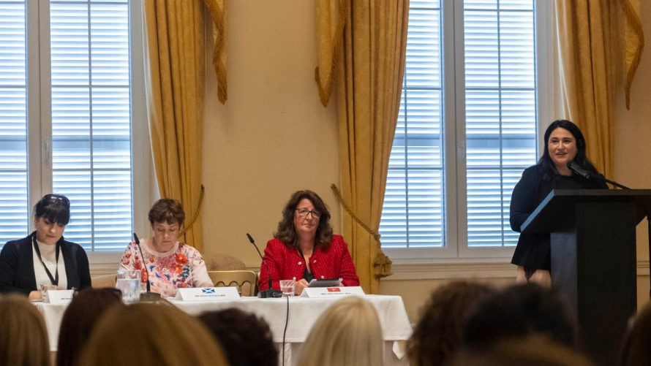
At an outreach session led by Samantha Sacramento MP Gibraltarian women with an interest in politics questioned women parliamentarians from the different branches in the region about their experiences. The panel, including Rhianon Passmore MS, Ann Corlett MHK, and Sarah Boyack MSP gave frank accounts of the positives and challenges they have faced during the electoral process and in office. The session was positioned to encourage women to stand for election and take a more active role in politics. Members of the panel highlighted that the growing number of women in politics had led to legislative change and made it easier for women to be parliamentarians. Barriers the parliamentarians faced included the power of incumbency, and the lack of care infrastructure in parliaments.

Opposition Spokesperson for Equality in Malta, Graziella Attard Previ MP, highlighted how the power of incumbency had affected her. "What kept me going in politics is my determination," she told attendees.

In the audience were women from a cross-section of the local community, from all political parties, or with no political affiliation. Also present were Gibraltar’s male members of parliament, including the Chief Minister, Fabian Picardo and Leader of the Opposition Keith Azopardi.

After the session, Samantha Sacramento stressed the importance of having more women in the legislature. In recent times she has proposed parliamentary reform for parental leave to be legislated. No woman has ever been pregnant or had a child while serving as an MP in Gibraltar.
"No one's actually thought what to do when that time comes," she said. "So my ambition was to have a framework and a structure in place for people should want to [have a child], then they know what's coming and they know how it would work."

Marlene Hassan Nahon MP said Gibraltar has "deep rooted social injustices" and the way forward for women in politics is to legislate. She called for paternity laws which will remove the childcare burden from women and create more equality in families. "There has to be more proactivity from leadership to put women in positions of power," she said. She echoed the message that men need to support women, but also called for women to come forward. "It's a vicious circle. As long as women don't come forward, they are not going to be taken seriously," she said.

Gibraltar's Commonwealth Youth Parliament delegate, Adriana Lopez, found it inspiring to see the number of local women interested in politics. "On a personal level this afternoon has been inspiring because I can see the conversations that we are used to having are finally more tangible," she said.

Words taken from an article by Gabriella Paralta in the Gibraltar Chronicle published on 10 October 2022

