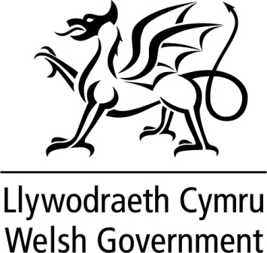

WRITTEN STATEMENT

BY

THE WELSH GOVERNMENT

TITLE | Support for businesses in dealing with Covid-19
DATE | 17 March 2020
BY | Rebecca Evans AM, Minister for Finance and Trefnydd

The Welsh Government is today announcing a package of support worth more than £200m for small businesses to help them during the coronavirus outbreak.

Retail, leisure and hospitality businesses with a rateable value of £51,000 or less will receive 100% non-domestic rates relief and pubs with a rateable value of between £51,000 and £100,000 will receive a £5,000 reduction on their bill. Under this new scheme, 20,000 businesses will pay no rates at all in 2020-21.

A further £100m will be available for a new grant scheme for small businesses.
Further details on this new grant scheme will be confirmed as soon as possible.

This support will operate in addition to our existing £230 million package of rates reliefs. It makes full use of the consequential funding for Wales resulting from announcements in the UK Government’s Budget on 11 March.

The Welsh Government has written to the Chancellor of the Exchequer, suggesting a range of very major interventions which we believe are needed to stabilise the economy and reassure individual citizens that they will receive financial support when they need it.

https://twitter.com/fmwales/status/1239920266899271683

