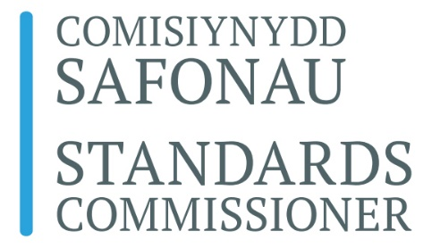

Complaint Form.

NOTES
- You do not need to use this form to make your complaint but doing so may help to ensure that you provide all the necessary information.
- If you need help to complete this form please telephone the Standards Commissioner’s office on 0300 200 6542. Please note that the Commissioner cannot advise you on whether you should make a complaint or on what you should say in it.
- Information in bold must be provided if your complaint is to be admissible. You do not have to provide the other information but it may speed up the processing of your complaint if you do.
- Please read Complaints Procedure before completing this form.
- Please send the completed form and your supporting evidence to Standards.Commissioner@senedd.wales

YOUR DETAILS
Title: Mr/Mrs/Miss/Ms/Doctor/Other (please specify)
First Name: Surname:

Postal Address:

Postcode:

E-mail:

COMPLAINT DETAILS

What is the name of the Senedd Member you are complaining about?

First name: Surname:

What conduct of the Member do you say breached the rules of conduct?
Please describe in detail each act or omission of the Member that you allege broke one or more of the provisions in Code of Conduct.

Please continue on separate sheet if necessary
When and where did each act or omission take place?

Which rule of conduct do you say was broken by each act or omission of the Member?
It is sufficient to give the number of the Rule.

Supporting evidence: You must attach sufficient documents or other evidence to satisfy the Commissioner that there is a prima facie case that a Rule of Conduct was broken. You should also attach the name and contact details of any witnesses whom you believe will be able to provide supporting evidence.
Further information: Insert here any further information that you believe would assist the Commissioner in considering your complaint. Please continue on separate sheet if required.

